ublication of ALOA—An Intern|tional Association of Security H

December 2

:

PLUS!

Eric Costley Gets His Day in Court  
Installing a Door Closer on a Security Gate  
Door Lock Compatible Cylinders  
Electrical Safety

**Important Information About Vour PRP Certification and  
ALOA Membership**

Forensic Locksmithing

***************SCH 3.DIGIT 303 Breck H. Camp Cml PO Box 47070 Atlanta GA 30362-0070

lull'll lllllllllllllll I,ill llllllllllllllllllllllllillllllll

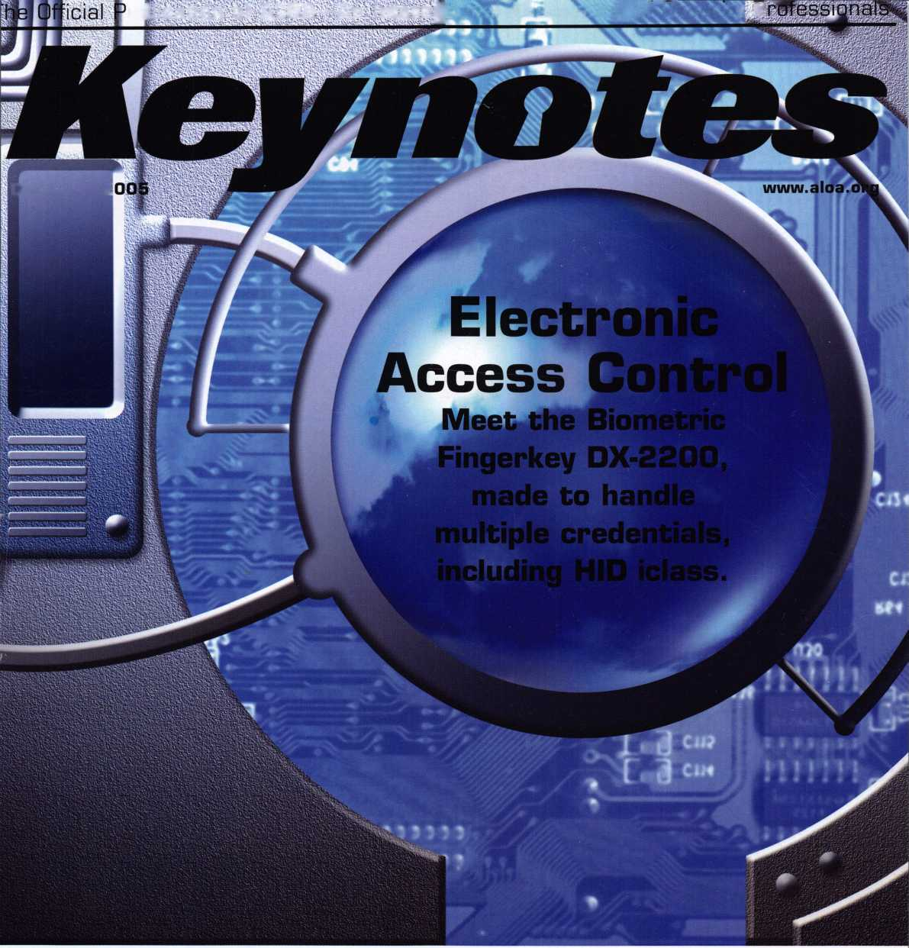

OUR STAND

You’re in good hands.

*LOcksmiths*

**any, Irving, "X. Allstate New Jersey Insu  
Late Insurarce Company, Northbrook, IL**

**trance CorrjHpBP^mtate Indemnity Company, Northbrook, IL. Allstate County Mutual Insurance Comp PlSli^^JStered service mark and "Our Stand" is a service mark of Allstate Insurance Company. ©2005 Alls**

**-ance**

**IT’S QUITE POSSIBLY YOUR MOST**

**TRUSTED SIDEKICK.**

Keep it in Good Hands® with Allstate.

As a small business owner, there are few things you rely on more than your vehicle to keep you going. Your local Allstate agent can help protect it and your small business with services you need including

quick certificates of insurance, ID cards, assistance with the claims process, and more. All from one of the most widely recognized names in the business.

Are you in Good Hands®?

1-800-859-0247

CALL NOW TO LOCATE YOUR NEARBY ALLSTATE AGENT.

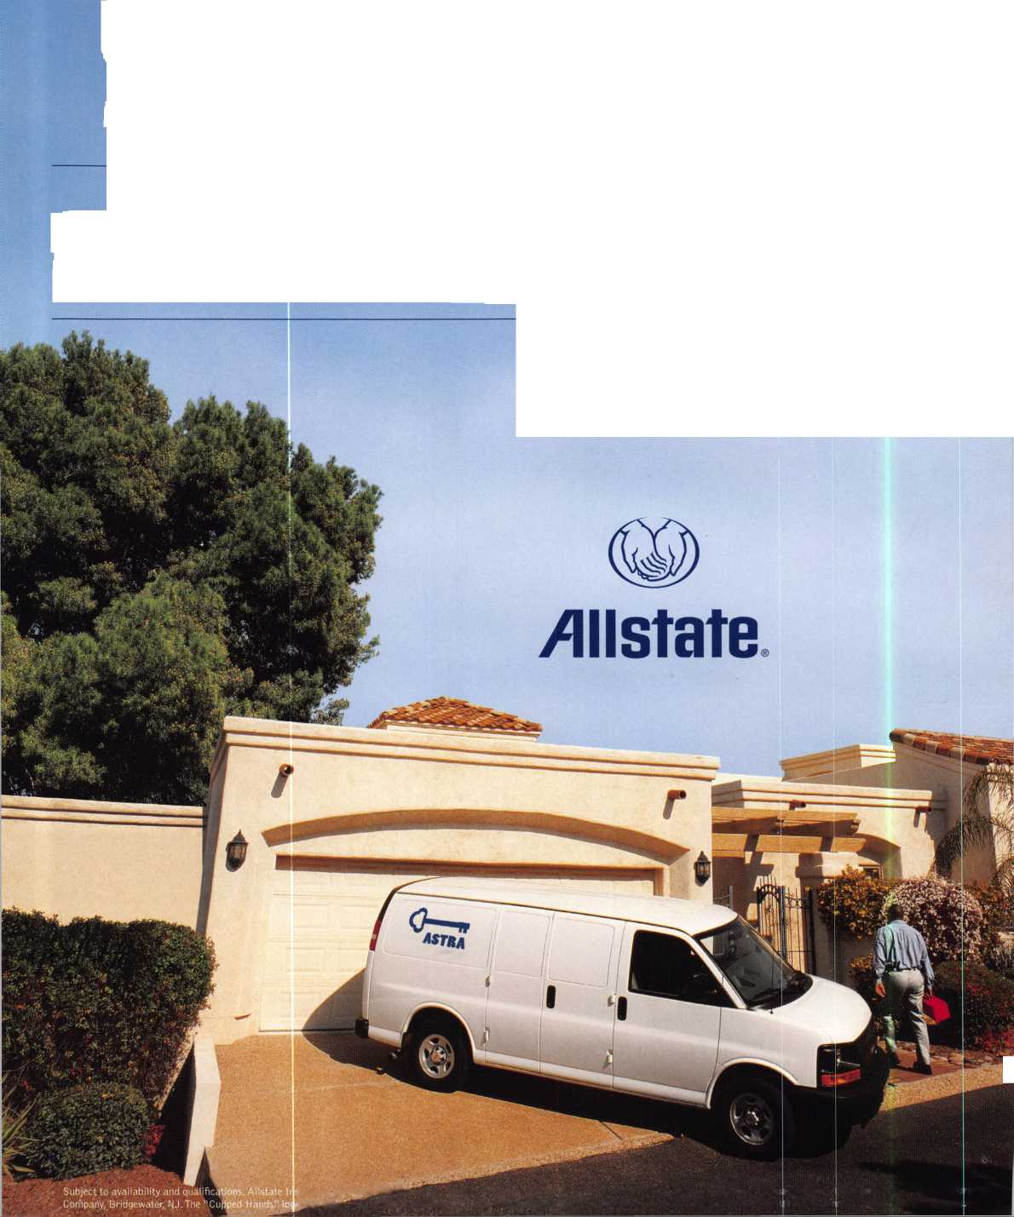

A Name You Know

As a business owner, you know the importance of a good name. Your name is your reputation. Your name stands for all that you offer in products and services. It’s a symbol of who you are. So, we thought you might like to know that Allstate, the name you know for insuring your personal vehicle and your home, also offers a business auto policy to help protect vehi­cles used in your locksmith business.

The following are coverages typically included in our business auto policy that might be important to you as a business owner:

Business Auto Liability coverage

* Higher limits up to $2,000,000 per occur­rence.
* Protects you if you are legally responsible for injuries and damages arising out of the ownership, maintenance, or use of business vehicles.
* Cost is based on several factors, including garage location, type and use of vehicle, and the violation and accident activity of your drivers.
* Additional Insured coverage may be required when you contract with govern­mental agencies or bid on local commercial jobs.
* Generally not available on a personal auto policy.
* Usually is no charge to add an insured to a Commercial Auto policy.

Hired Auto coverage

* Provides liability coverage for those vehicles you rent, hire or borrow for business use.
* The premium for hired auto liability coverage is based on the estimated annual rental cost.
* Tools and Special Equipment
* Provides protection to permanently attached equipment on your vehicle.
* You will need to let your agent know the value of the equipment to include in the cost of the vehicle.

You’re good at your business. Your insurance com­pany should be the same way.

Contact an Allstate agent to discuss your business auto insurance needs. To be referred to an agent, please call 800.859.0247 or email

[abisO@allstate.com](mailto:abisO@allstate.com).

Subject to availability and qualifications. Insurance coverage is subject to policy terms.

Allstate Insurance Company

Allstate Indemnity Company Northbrook, IL

Allstate County Mutual Insurance Company Irving, TX

Allstate New Jersey Insurance Company Bridgewater, NJ

allstate.com

© 2005 Allstate Insurance Company, Northbrook, IL

BETTER  
THAN EVER.

This Hawkeye® Borescope

includes all of the latest upgrades for safe and vault professionals: Optics that deliver images that rival German scopes. A new mirror technology that resists scratches from insulation, asbestos, and burrs. And a mirror protection sleeve to ward off dust.

Plus the option of the GRAND KIT with a fully configured 7” and 17” scope in one case. Or the economy minded LE model.

The red eyecup tells you that you have the scope made specifically for safe and vault professionals.

Available from Gradient Lens resellers to the safe and vault industry only.

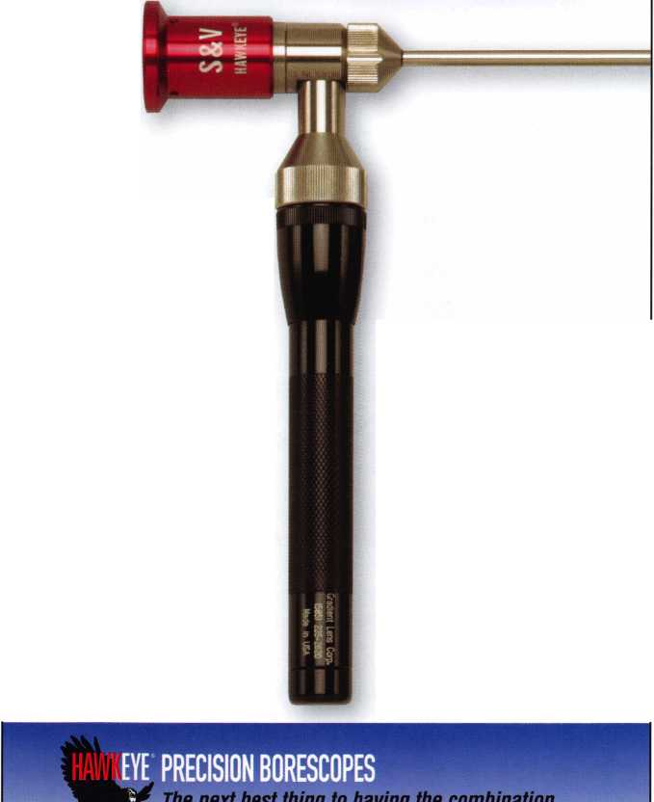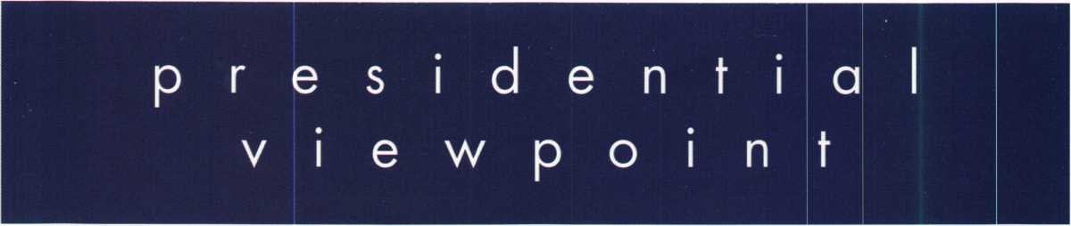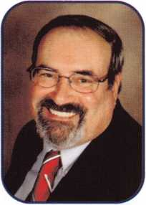

Dear Members,

Season's Greetings!

This is the time of the year when many people give and receive gifts. If I could give a gift to each of our members, it would be that of health, happiness and prosperity. If I were to receive a gift, my hopes are that it would be that of communication, cooperation and commitment by all of us in the security industry. What a gift to ourselves — working together for an industry that we all love.

Home for the holidays is a thought that comes to mind at this time of year. And what a home com­ing ALOA had! Our headquarters held an Open House during our Fall Board Meeting. The Board got a chance to take a brief break and visit the HQ. The Open House was a great success. I met with some of our members and the terrific staff that works at the main office. The new headquar­ters is fantastic. It is not only larger, but more updated than the old one witlh plenty of room to expand. The museum and library are progressing and should be a "must see" if you ever visit the Dallas area.

Our own Executive Director, Charles Gibson, was honorary chairman of the Greater Philadelphia Locksmiths' Association's 56th convention. The theme of the banquet was "A Salute to the Men and Women of the Armed Services". Mr. Gibson is a retired colonel in the Army. The "Colonel", as he is affectionately known to us, received the "Lee Rognon Award" for promoting communica­tion and cooperation among locksmith associations.

As the year winds down to its end and our association is heading into its 50th year, let's all make plans to attend the convention in Las Vegas. Think about driving home in that '56 T-Bird. Now, that's a gift!

Take 'er easy!

Sincerely,

Robert E. Mock

**2**

Keynotes

December 2005



*Peterson*

*locksmith Tools*

***AUTOMOTIVE WT***

**A imiliy LOOKERAFT**

***&kSP) HATA***

***DETERMINATOR MAJOR (0™\****

Jk, PRD-LI

HH STRATTEC ^ • ... ,

^TECK *Wed$ee&°*

**CAL-ROYAL**

Jim*-*™

jiutsoil

**3$**

LCN

**MONARCH**

**SCHLAGE**

**VON DUPRIN**

*roots*

a* *BMHOtl*

AAWJ;

Inc «*«*>»-

**AVENGER**

BOXER

fe^uletefToolCo.

" C ^

V *3tair

***Why Do  
Locksmiths  
Everywhere Buy  
Supplies at***

***H.L.FIake?***

*$ Extremely Competitive*

# E/Z *Free Freight Minimums*

*tfc Same Day Shipping  
% Service with a Smile  
% High Fill Rate  
$ Hard to Find Items*

**LOCKCRAFTj£j**

OCK IECHNOLOGY

***MAJOR***

**PRu-LuK**

*[www.niriRBt.cum](http://www.niriRBt.cum)*

* *Order 24 hours a day*
* *Updated Every Business Day*
* *Extra Discount for Web Orders*
* *Personalized Inventory Lists*

***LOG ON TO*...**

[WWW.HIFIMKE](http://WWW.HIFIMKE). com

Q|Q«ife tfi&Ct

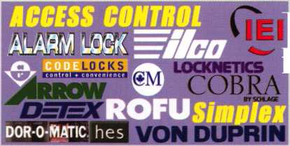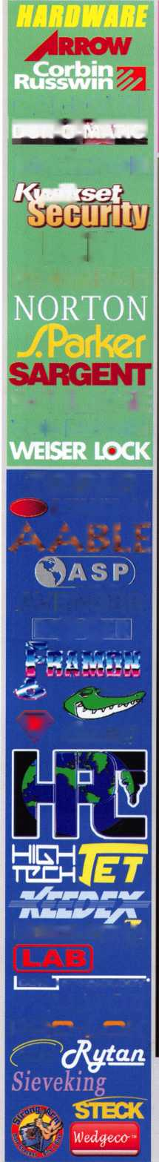

feat

ELECTRONIC LOCKS 2005



**14**

Electronic Locks:

Biometric Fingerkey DX-2200

Found out how the latest advancement in Recognition Systems can provide a greater sense of security for you.

Installing A Door Closer on a Security Gate

Gordon Racine addresses the problems with trendy exteri­or locking gate systems on many of todays commericial buildings.

by Gordon Racine, CML

**16**

American Lock:

Door Lock Compatible Cylinders

After many years American Lock is now offering a wide variety of cylinders and cores with keyway compatibility. See which is the best fit for you.

by Billy B. Edwards Jr., CML

*20*

*22*



**30**

Electrical Safety

Many dangers are lurking behind each corner waiting to pounce when given a chance. Find out what you can do to avoid common pitfalls and also learn the best safety tips.

by Greg Perry, CML, CPS

PRP Certification/ALOA Membership Info

Do you know if you need to be recertified? Know the facts.

A Day in Court

Find out when the great gavel of fate finally came knocking on Eric Costleys door to testify in a court of law.

by Eric Costley, CPL

Forensic Locksmithing

Over the years the face of Locksmithing has changed vastly. Read how Forensic Locksmithing has become a much a much needed skill in law enforcement and elsewhere.

by Dan Cunningham, CRL, CFL

U

res

**AD INDEX**

**Allstate.**

**Inside Front Cover**

**Gradient Lens 1**

**HL Flake**

**Safetech 2006 7**

**MLANJ 11**

IR

**13**

**ALOA 2006 19**

**KABA llco 27**

**TLA**

**CCL**

**Dugmore and Duncan. Hinge Doctor A&B Safe**

**PBP**

**Keedex**

**Payment Retriever**

**Ultralift**

**CompX**

**Hickok**

In

**33**

**33**

**37**

**41**

1. **42**

**42**

**42**

**43**

**side Back Cover**

**Back Cover**

**Departments**

|  |  |  |  |  |  |  |  |  |  |
| --- | --- | --- | --- | --- | --- | --- | --- | --- | --- |
| Presidential |  | Exec | utive | 5 | Calendar | 8 | Classified | 36 | Legislative 40 |
| Viewpoint | 2 | App | icants .... | 6 | Core | 9 | Associate Members | 38 |  |

Visit our NEW website at [www.aloa.org](http://www.aloa.org)

**executive**

Volume 53, Issue 12

Additional contact information for the ALOA Board and most Keynotes authors is  
available through "Locksmith Search'" on the ALOA Web site- [www.aloa.org](http://www.aloa.org) or by  
contacting the ALOA office at 3500 Easy Street; Dallas, TX 75247; (800)532-2562; FAX  
(214)819-9736; e-mail [aloa@aloa.org](mailto:aloa@aloa.org).

Editor

Betty Henderson [betty@aloa.org](mailto:betty@aloa.org)

Advertising Sales

Kim Hammond voice: 817-645-6778

Fax: 817-645-7599 e-mail: [adsales@aloa.org](mailto:adsales@aloa.org)

Executive Director

Charles W. Gibson, Jr., CAE [charlie@aloa.org](mailto:charlie@aloa.org)

Associate Executive Director

David Lowell, CML, CMST [david@aloa.org](mailto:david@aloa.org)

Convention & Meetings Manager

Jo Anne Mims [joanne@aloa.org](mailto:joanne@aloa.org)

Operations/Membership Manager

Mary May [mary@aloa.org](mailto:mary@aloa.org)

Director of Creative Services

Betty Henderson [betty@aloa.org](mailto:betty@aloa.org)

IT Operations Manager

Greg Jackson [greg@aloa.org](mailto:greg@aloa.org)

Comptroller Kathy J. Romo

Membership Coordinator Shelly Jett

Convention & Meetings Assistant Karen Lyons  
PRP/Education Coordinator Hope Rodriguez

Mail Room Coordinator Kevin Wesley

Creative Media Specialist Margarita Garza

Accounting Coordinator Joyce Nixon

Executive Assistant Sue Langford

Assistant Education Manager Bob Stafford

Legislation Manager Tim McMullen

Contributors

Jerome Andrews, CML  
Paul Chandler, CRL  
Claire Cohen, CML  
Brian Costley, CML, CMST  
Eric Costley, CRL

Ray D'Adamo, CML Billy Edwards, CML Dan Graffeo, CRL,CMST Jim Hancock, CPL Jeff Nunberg, CML, CMST

Randy Simpson, CML, CPP Robert Stafford, CML Dave Thielen, CML Greg Perry, CML,CPS

Tom Seroogy

Charles Stephenson, CPS

Dennis Watanabe, CML, CMST

Mission Statement: The Associated Locksmiths of America, Inc. is dedicated to enhancing the professionalism, education and ethics among  
locksmiths and those in related sectors of the physical security industry. With approximately 10,000 members in the United States, Canada and the  
freeworld, ALOA is poised to help members obtain the knowledge, the strength, and the confidence to perform their role in the physical security field  
with pride and dignity. But it is only through active involvement and participation that ALOA can fully achieve its potential—and can help members to  
achieve theirs.

Policies: Keynotes® is the official publication of the Associated Locksmiths of America, Inc. (ALOA). Keynotes® acts as a moderator without approving,  
disapproving, or guaranteeing the validity or accuracy of any data, claim, or opinion appearing under a byline or obtained or quoted from an acknowl-  
edged source. The opinions expressed by the authors do not necessarily reflect the official views of ALOA. Also, appearance of advertisements and  
new products or service information does not constitute an endorsement of products or services featured by the Association. The Association does not  
accept responsibility for the inaccuracy of any data, claim, or opinion appearing in this publication, due to typographical errors on the part of the  
authors, Association staff or its agents.

Editor's Note: This publication is designed to provide accurate and authoritative information in regard to the subject matter covered. It is provided  
and disseminated with the understanding that the publisher is not engaged in rendering legal or other professional services. If legal advice and other  
expert assistance is required, the services of a competent professional should be sought.

Authors' Payment: Payment for eligible submissions to Keynotes will be based on the following criteria: topic, time spent and past contributions. Authors who  
regularly submit to Keynotes® are generally paid a higher rate. The latter is especially true of authors who write to fit specific editorial needs and submit said copy  
by Keynotes® deadlines. As a general guideline: Average payment for a 750 word, business or 'light' technical article would be $200. Payment for a 1500 word  
article involving significantly higher time and research efforts would be $400.

Payment will not be offered for articles submitted by ALOA employees or members of the ALOA Board of Directors (unless material is of a technical  
nature), nor for articles submitted by a company that promote that company's products or services. ALOA reserves the right not to pay for articles sub-  
mitted by an individual(s) that promote a particular company's products or services.

Disclaimer: The Associated Locksmiths of America, Inc., (ALOA), reserves the right to refuse any article for any reason. Additionally, ALOA reserves  
the right to edit, amend or modify any article submitted for publication in order to preserve technical accuracy, clarity, fairness or grammatical cor-  
rectness. ALOA will make the best efforts to notify the author of any changes. The extent of ALOA's liability for any article or information contained  
therein will be a notice of correction or retraction in the next possible issue.

Keynotes® (ISSN 0277 0792) is published monthly except for the combined June/July issue by The Associated Locksmiths of America, Inc.,  
3500 Easy St., Dallas, TX 75247-6416. Telephone: (214) 819-9733; FAX (214) 819-9736; e-mail [aloa@aloa.org](mailto:aloa@aloa.org). Subscription rates for  
members—$15.00 per year. Periodical class postage paid at Dallas, Texas. POSTMASTER: Send address changes to: Keynotes, 3500 Easy St., Dallas,  
TX 75247-6416. © Copyright 2003, All rights reserved. No part of the contents may be reproduced or reprinted in any form without prior  
written permission of the publisher.



President

Robert Mock  
(856) 863-0710

[president@aloa.org](mailto:president@aloa.org)

Secretary

John Soderland, CML, CMST  
(414) 327-5625  
[secretary@fefloa.org](mailto:secretary@fefloa.org)

Directors, Northeast

Peter Saraiiian, CRL  
[201)944-7547  
[nedirector@aloa.org](mailto:nedirector@aloa.org)

Vernon Kelley, CPL

1. 771-3126 [nedirector@aloa.org](mailto:nedirector@aloa.org)

Directors, Southeast

Tom Gillingham, Jr., CML, CPS  
(615) 264-0747  
[sedirector@aloa.org](mailto:sedirector@aloa.org)

Ken Kupferman, CML  
(813) 961-5784  
sed i rector@a loa. org

Director, North Central

William Smith, RL  
(920) 893-5282

Guy Spinello, RL  
(815) 394-1000  
ncd irector@aloa. org

Director, South Central

CD Lipscomb, CML, CPS  
(903) 874-3522

scdirector@aloa .org

Directors, Southwest

Gordon R. Racine, CML  
(719) 384-4707  
swd i rector@a loa . org

Julie McCluney, CRL  
(714) 636-5652  
swd i recfor@a loa. org

Director, Northwest

Jim Jeffries, CPS  
(877) 241-6978  
[nwdirector@aloa.org](mailto:nwdirector@aloa.org)

Director, European

Hans Mejlshede, CML  
(453) 539-3939  
eurdirector@aloa .org

Director, Asian

Joej. Lee, CRL  
(215) 289-2404  
[asiandirector@aloa.org](mailto:asiandirector@aloa.org)

Director, Associate

Paul M. Justen  
(612) 238-4646  
[asdirector@aloa.org](mailto:asdirector@aloa.org)

Trustees

[trustees@aloa.org](mailto:trustees@aloa.org)

Randy Simpson, CML  
(281) 240-5959

John I. Greenan, CML, CPS  
(773) 486.2030

William Young, CML, CPS

1. 647-5042



Past Presidents

2003-2005 William Young, CML, CPS  
2001-2003 Randy Simpson, CML  
1999-2001 John Greenan, CML, CPS  
1997-1999 Dallas C. Brooks  
1995-1997 David Lowell, CML, CMST  
1993-1995 Breck Camp, CML  
1991-1993 Henry Printz, CML  
1989-1991 Evelyn Wersonick, CML, CPS  
1987-1989 Leonard Passarelio, CPL  
1985-1987 Joe Jackman, CML  
1983-1985 Stanley Haney, CPL  
1981-1983 Louis LaGreco, CPL  
1979-1981 John Kerr, RL  
1977-1979 Clifford Cox, CML  
1974-1977 Charles Hetherington  
1972-1974 Gene Laughridge  
1970-1972 William Dufcher, RL  
1968-1970 Constant Maffey, RL  
1966-1968 Harold Edelstein, RL  
1964-1966 William Meacham  
1962-1964 Robert Rackliffe, CPL  
1960-1962 Edwin Toepfer, RL  
1956-1960 Ernest Johannesen



Keynotes • December 2005

s

AR

Harrison

John Villines

Hot Springs

William McCandless

Sponsor: David E. McCandless

CA

Chino Hills

Alfonso S. Arteaga CRL

Sponsor: Phillip E. Mossey Crowley Lake

Robert Pearce

Fresno

Robert D. Burden Jr.

FL

Cape Coral

Robert V. MacCarger

Melbourne

Gregory J. Horn CPL

Sponsor: James R. Easter CML  
Orlando

Joseph E. Smith

Sponsor: Ken Kupferman CML  
Zephyrhills

Greg S. Belles

Sponsor: Ken Kupferman CML



Decatur

Michael S. Rollins

Sponsor: Dewayne A. Heidemann CRL Highland Park

Patrick T. McGahan

KS

Lenexa

James V. Ballew

MD

Annapolis

William Dow

Sponsor: Dan S. Sousa

Baltimore

Carmen R. Mirabile

Sponsor: Charles L Hill CRL Gaithersburg

Alberto L. Cruz

Sponsor: Michael C. Olson CRL Jessup

Amber Asimenios

Sponsor: Robert D. DeWeese CML

MO

Raymore

Vernon Guilford

Sponsor: Joseph E. Buckingham

MT

Butte

David Shaw

NC

Kill Devil Hills

Jerry D. Murray

ND

Grand Forks

David T. Noye CRL

Sponsor: James K Bisson CRL

NV

Las Vegas

Jon Malec

Sponsor: James A. Caster Bronx

Lap Quan

OK

Enid

Daniel L. Walters

Sponsor: James L. Hancock CPL  
Langley

Lloyd N. Simmons

Sponsor: William Lee CRL

PA

Philadelphia

Edward R. Aguilera

Sponsor: Joseph D. Borish Sponsor: Kevin M. Convery

TN

Cross Plains

Tracy Gatwood

Sponsor: Patrick A. Zywicki Sponsor: Kevin M. Convery Good lettsvi lie

Harold Haney

Sponsor: Robert W. Duman Sr. CML Nashville

Mats Jalmhagen

VA

Alexandria

Abubakarr Turay

Sponsor: Michael C. Olson CRL Woodbridge

Paul J. Kelly

Sponsor: Michael C. Olson CRL

WA

Mercer Island

Mark Kaehler

Sponsor: J. Casey Camper CML, CPS

Wl

Medford

Jack R. Machon

Sponsor: J. Casey Camper CML, CPS  
Middleton

Han Fossum

Sponsor: J. Casey Camper CML, CPS

Canada

Yellowknife

Paul Ollerhead

[England

Tyne & Wear

Stuart Gyger

Sponsor: Ken Dale

North Irelan

Strabane, Co. Tyron

Terence Miahon

These applicants are scheduled for clearance as members of ALOA. The names are published for member review and comment within 30 days of this Keynotes issue date, respectively, to ensure  
applicants meet standards of ALOA's Code of Ethics. Protests, if any, should be addressed to the Membership Department and must be signed. Active Membership applicants (a) have worked in  
the industry two or more years. Allied Membership (AL) applicants are not locksmiths, but work in a security-related field. Apprentice Membership (AP) applicants have worked in the industry less than two years.

Keynotes • December 2005

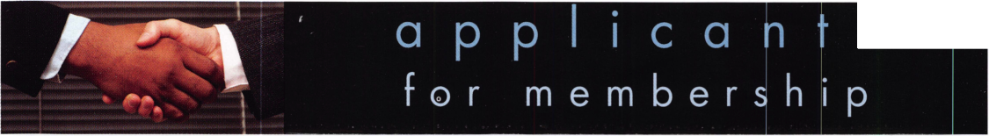

**REACHING NEW HEIGHTS**

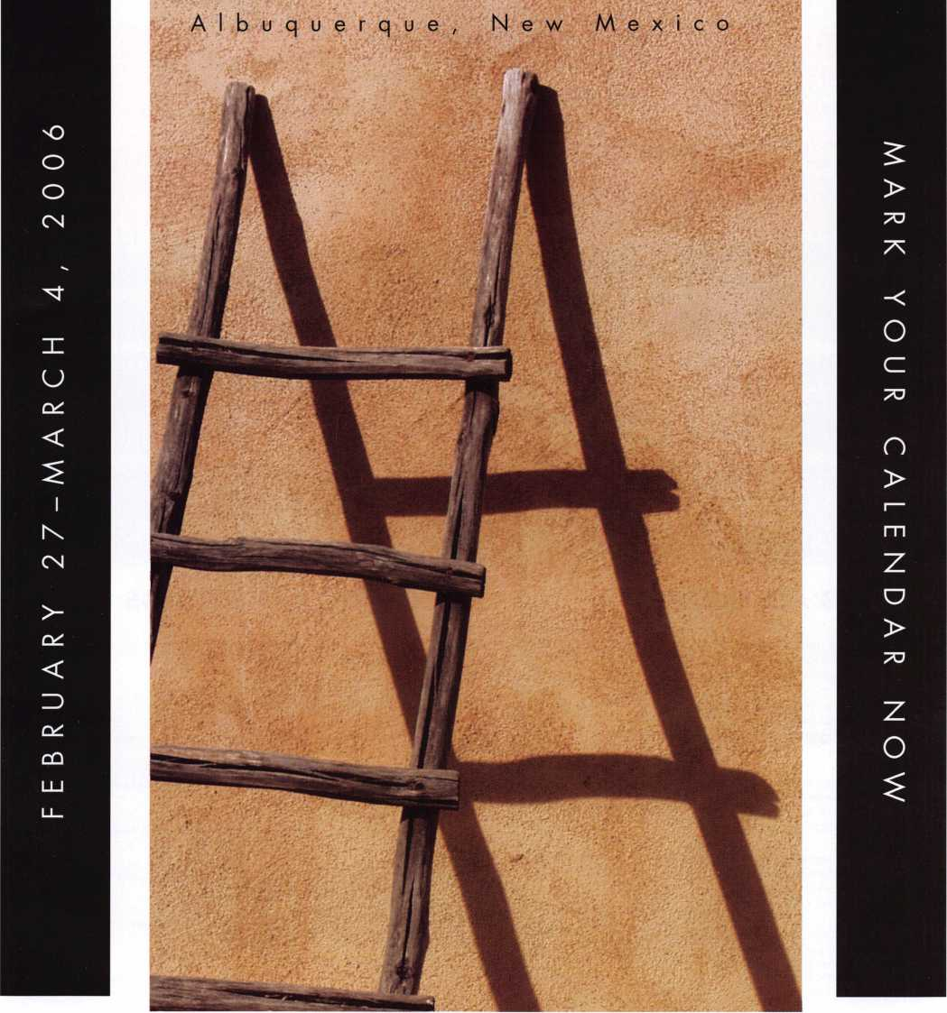

When it comes to learning about the latest in safes and vaults, time is of the essence. SAFETECH 2006 features an all-new menu of classes, covering every safe topic on the globe. Don't miss out!

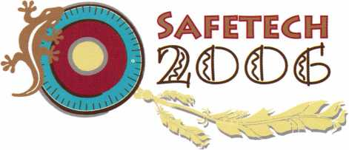

SAVTA • 3500 Easy Street • Dallas, Texas 75247 (214) 827-SAFE (7233) Fax (214) 819-9736 Email: [convention@savta.org](mailto:convention@savta.org)

**MAR I FEB I JAN I DECEMBER**

upcoming events

|  |  |  |  |  |
| --- | --- | --- | --- | --- |
| 5-10 Dallas, Texas  Six-Day Basic  Locksmithing Course  Contact: Hope Rodriguez  Phone: 800-532-2562x104 | 7 Oklahoma Fire & Burglar Alarm 8 PRP Exam  State Advisory Committee Meeting ALOA Headquarters  10:30 am Dallas, Texas  Oklahoma City, OK Contact: Hope Rodriguez  Phone: 800-532-2562x30 | HHHHHHIHHHH | |  |
| 21 NJMLA Monthly Meeting Third Wednesday of every month Call (201)944-7547 or (201)947-6291 for time and location. | ' . ' ' ' ' : ' ' ■ ■ .. |  |  |  |
| HHHHHHiHHHHHHHH^ | | | |  |
| 10-12 Minnesota Chapter Associated Locksmiths of America  Education Weekend  Reservations, 651 -770-2811 Maplewood, MN |  | | | |
| 1-4 SAFETECH 2006  Safe & Vault Technicians Assc. Annual Convention 2/27-3/4 Contact: [convention@savta.org](mailto:convention@savta.org) Albuquerque, NM |  | | | Hi |

**UPCOMING ACE CLASSES UPCOMING PRP SITTINGS**

|  |  |  |  |
| --- | --- | --- | --- |
| 12/5-10/2005 | Dallas, Texas • ALOA ACE Program  Hope Rodriguez 800-532-2562 xl04  6 day basic locksmithing course | 12/08/2005  1/12/2006 | Thursday 9:00 am • Dallas, TX • ALOA  Hope Rodriguez 800-532-2562  Thursday 9:00 am • Dallas, TX • ALOA |
| 1/13-14/2006 | Casper, Wyoming • ACE Classes  Wyoming Locksmiths Association |  | Hope Rodriguez 800-532-2562 |
|  | Contact: Darren McFarland, CRL  307-899-6018 | 2/12/2006 | Sunday 9:00 am • Maplewood, MN • Minnesota Chapter  Dana Lee 952-887-1199 |
| 2/11/2006 | Detroit, Michigan • ACE Classes  Locksmiths Security Association  Contact: Robert C. Nobel, CPL | 2/12/2006 | Sunday 8:00 am • Ft. Worth, TX • Texas Locksmiths Association 877-TLA-INFO |
| 2/10-12/2006 | 810-385-9329  Minneapolis, Minnesota • ACE Classes | 2/26/2006 | Sunday 9:00 am • Fairborn, OH • Ohio Valley Chapter of ALOA Bill Lockwood, CRL 937-775-2154 |
|  | Minnesota Chapter of ALOA  Contact: Dana Lee, CML  612-968-4500 | 3/04/2006  3/18/2006 | Saturday 8:00 am • Albuquerque, NM • SAVTA '06 Satetech Hope Rodriguez 800-532-2562  Saturday 11:00 am • Somerset, NJ • MLANJ |
| 3/16-19/2006 | Secaucus, New Jersey • ACE Classes  East Coast Region Security Show  Contact: Bill Timmann, CML  908-859-3135 |  | Bill Timmann, CML 908-839-3135 |

**o**

core

GPLA Presents Awards

The Greater Philadelphia Locksmiths Association recently present awards at the GPLA 56th Annual Awards Banquet.

The Philadelphia Award was presented to Mark Miller for devoting much time and effort to the advancement of the craft, not only in Philadelphia, but around the world.

The Gerald J. Connelly Jr. Pioneer Award was presented to William Boyd Neff, CML as recognition for his professional dedication to the locksmith industry in the categories of leadership and education.

The Lee Rognon Award was presented to Charles W. Gibson Jr., CAE

for his efforts promoting professionalism and fostering cooperation between associations.

The Herman Henssler Award is reserved for Members of the Greater Philadelphia Locksmith Association who have made exceptional contributions to the growth of the Association. Named for a founder of both GPLA and ALOA, it is the consummate expression of respect by the Association for one of its own. This year, the recipient was Dolores Mock.

Sargent and Greenleaf To Be Featured On Made **In America**

Sargent and Greenleaf (S&G), a subsidiary of Stanley Security Solutions, Inc., will be featured on the popular television program Made in America. Hosted by John Ratzenberger, best known as the know-it-all mailman Cliff Clavin on the pop­ular television series Cheers, Made in America highlights companies from all across the United States that manufacture products in America.

The Sargent and Greenleaf segment will air December 27th as part of the show's new 2006 season. Ratzenberger spent the day inside the S&G factory, meeting employees and actually working on the production lines. He then took a guided tour of S&G's newest products, including the Biometric Keypad, an innovative device that controls safe locks by fingerprint.

Made In America airs on Tuesdays at 9:00 p.m. (Eastern Time) on the Travel Channel.

In Memory

Harry L. Crile of Pat's Key and Lock in Hutchinson, KS and Ronald L. Fowler, CRL, an ALOA member since 1985 passed away this year leaving friends and rela­tives to sadly celebrate their memories.

New Product News

CCL Security Products, a divison of The Eastern Company of Naugatuck, CT, recently introduced the Super Sesamee™ to the security marketplace at the Institutional Locksmith Association Conferences held in Chicago and Secaucus, NJ in October.

Developed at the request of institutional and industrial users of 4-dial combination padlocks, the Super Sesamee offers all of the benefits of a solid steel padlock, with the weather resistance of an all brass padlock.

Locksmiths may purchase Super Sesamees from all participating Security Hardware Distributor Association (SHDA) members.

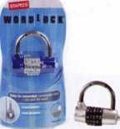

Champion Speller

The WordLock is a combination lock that uses letters

instead of numbers. Instead of the numbers 2468,  
for example, the lock could spell "lawn." The benefit  
to users is that words are much easier to remember.  
The lock can be used in many applications-as a  
padlock, a lock on a briefcase or laptop, or even a  
door lock.

WordLock was recently selected as the grand prize  
winner in Staples® first-ever Invention Quest™ con-

test. An expert panel of judges, along with more than 147,000 online votes cast  
by America, selected WordLock as the #1 product for 2004.

WordLock was one of the top 100 new inventions in the Invent Now America competition hosted by the PTO and QVC.

WordLock can be created in any variety of themes from sports to branded char­acters and can be created in any number of languages including Spanish,

French, Italian etc. Learn more about this product at <http://www.wordlock.com/>.

DeWALT named One of Top Ten Best Brands by **Fortune** Magazine

DeWALT, a leading manufacturer of industrial power tools, was named by FOR­TUNE magazine as a "2005 Breakaway Brand." FORTUNE turned to Landor Associates, a brand and design consultant in San Francisco, and BrandEconomics, a division of global consulting firm Stern Stewart & Co., to con­duct the study to determine which brands have been most successful at increasing their value. The findings appeared exclusively in FORTUNE magazine's October 31 st issue, available now at [www.fortune.com](http://www.fortune.com) and on newsstands.

Landor and BrandEconomics studied more than 2,500 brands in the U.S. BrandAsset®Valuator database to identify those brands that exhibited the greatest increases in brand strength over the three-year period from 2001-2004. The study evaluated brand strength, which is a combination of differentiation — how well the brand stands out from others —and relevance—the degree to which consumers believe a brand meets their needs. The study also measured each brand's stature. Brand stature is broken into two components, esteem and knowl­edge. Esteem is how well regarded the brand is, while knowledge refers to whether the consumer understands the brand. DeWALT was chosen as one of the top brands as a result of superb brand strategy and execution.

The FORTUNE article called the DeWALT brand strategy, "Knowing Your Customer". It is this strategy that DeWALT has consistently executed since its rein­carnation in 1992. The intense focus on the needs of the professional power tool user has enabled DeWALT to quickly become one of the world's leading manufac­turers of industrial power tools.

DeWALT was ranked among some of the world's leading brands such as Google, iPod, Sony Cyber-shot, Gerber, Subway, BP, LeapFrog, Sierra Mist, and Eggo.

Keynotes • December2005

Biometric FingerKey

DX-2200

Handles Multiple Credentials, Including HID iClass

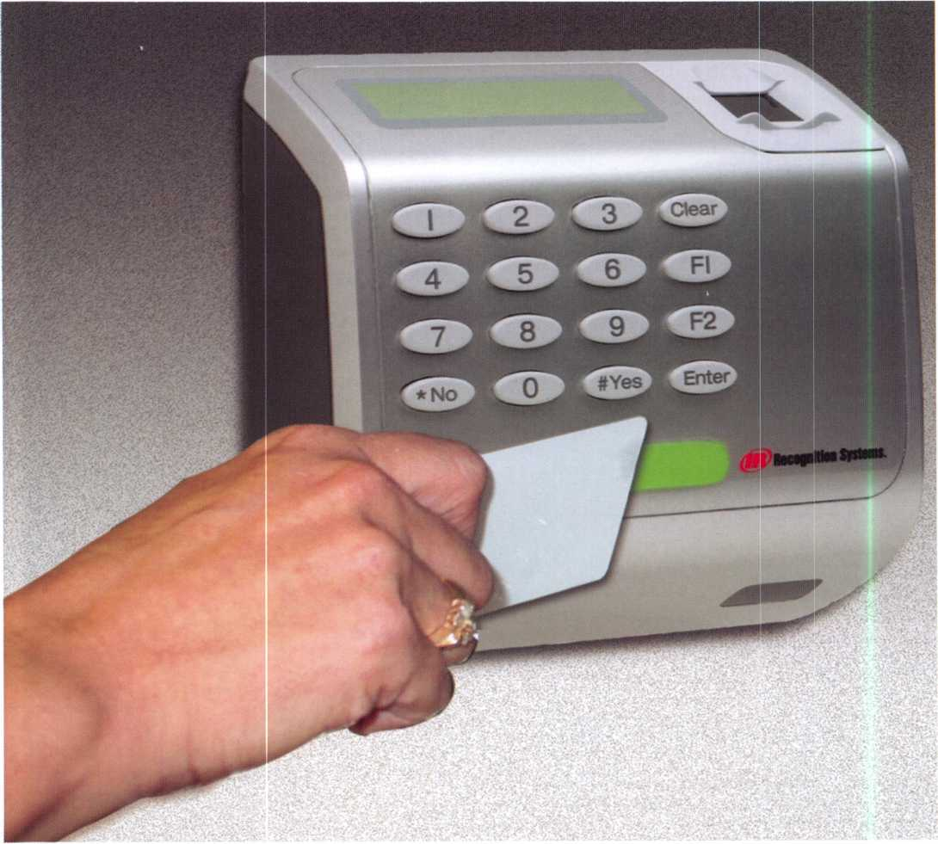

Keynotes • December 2005

The Master Locksmiths  
Association Of New Jersey

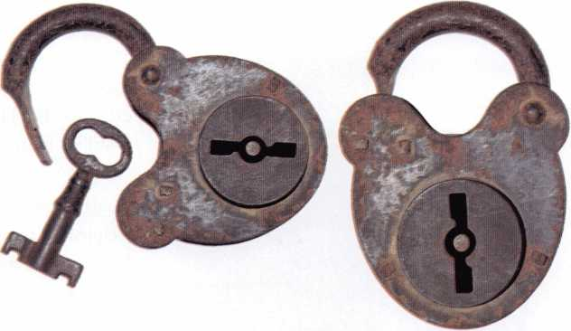

2006

East Coast Regional  
Lock & Security Show

(Classes, Trade Show, and Banquet)

March 16th thru March 19th

Crowne Plaza Meadowlands Hotel  
2 Harmon Drive  
Secaucus, NJ 07094

For more information:

P.O. Box 2441

Morristown, NJ 07962-2441  
Fax 973-538-1588 or visit [www.MLANJ.org](http://www.MLANJ.org)

With Smart Cards, Fingerprint Readers Provide Greater Security and Biometric Template Portability

Recognition Systems, the biometric component of  
Ingersoll-Rand's (IR) Security Technologies, recently  
announced that an integrated HID iCLASS card reader is  
now an option available for its FingerKey DX family of  
products. These biometric finger scanners work with a  
variety of credentials including proximity, magnetic stripe  
and now HID iCLASS con-  
tactless smart cards, through  
its FingerKey DX-2200  
model.

2^ C 3 ,

E! ES s

4

Oik

v:

"Offering integrated HID  
iCLASS card readers makes  
our finger scanners even  
friendlier to existing and  
future electronic access con-  
trol systems," explains  
William Kennedy,

Recognition Systems product  
marketing manager for access  
control. "The FingerKey DX-

2200, along with our already proven HandKey II with integrated smart card option, provide greater security and biometric template portability for our hand geometry and finger scanning technologies."

HID iCLASS contactless smart cards store both the user’s ID number and fingerprint template on the card, elimi­nating the need to distribute templates across a network or require the access control system to manage biometric templates. This means integration to existing access con­trol applications is greatly simplified and there are no additional network infrastructure costs. Because the tem­plate resides only on the card, the solution also eases indi­vidual privacy concerns.

The FingerKey DX family of biometric access control readers provides low-cost biometric alternatives designed to secure smaller user populations. The FingerKey DX includes a keypad and LCD display. Expanded memory

and Ethernet options are also available. Verification takes  
less than two seconds. The user simply enters a PIN code  
or presents a card, which calls up a template to scan or  
pulls the template from a smartcard. Then, the user  
places a finger on the FingerKey reader for verification of  
the template.

Along with the new FingerKey DX-2200 iCLASS,  
Recognition Systems also offers the FingerKey DX-2000,  
which uses a keypad or external reader for template verifi-  
cation, and the FingerKey DX-2100, which has an inte-

grated HID proximity reader.

The variety of options provided by  
Recognition Systems creates an  
extremely flexible combination of  
solutions for most applications.

Recognition Systems was named  
recipient of the 2004 Application  
Market Penetration Leadership  
Award for access control and time  
and attendance applications in  
Frost & Sullivan’s study, World  
Biometrics Market.

About Recognition Systems

With over 100,000 hand geometry units throughout the  
world reading millions of hands each day, IR Recognition  
Systems, founded in 1986, is the pioneer and only manu-  
facturer of the leading two biometric technologies, hand  
geometry and finger scan. The world sales leader of bio-  
metric verification devices for access control, time and  
attendance and identification applications, it serves an  
international clientele from its headquarters in Campbell,  
Calif. Its website is [www.handreader.com](http://www.handreader.com). Phone is  
408-341-4100. Recognition Systems is a business/busi-  
ness unit of diversified industrial-firm Ingersoll-Rand  
Company Limited, a leading innovation and solutions  
provider for the major global markets of security and safe-  
ty, climate control, industrial solutions and infrastructure.  
Further information on IR can be found on the compa-  
ny's web site at [www.irco.com](http://www.irco.com).

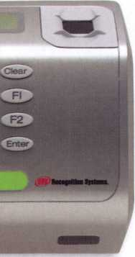

Keynotes • December 2005

SECURITY HOMEOWNERS WANT. That’S WHY IT’S ALL YOU NEED TO CARRY.

fggttMMf

*mmm*

*Introducing the Schlage* Accents™ *Collection*

Schlage now provides you with the ability to retrofit virtually any door with the ultimate in elegance and security. The Schlage Accents collection is built on a revolutionary chassis designed to provide field-reversible levers on passage, privacy and now keyed functions. A patented adjustable through-bolt allows Schlage Accents handlesets to retrofit over 70% of competitors’ current designs. Special features like these, along with concealed screws and decorative trim, allow you to reduce the inventory you carry while providing the perfect door hardware choice for homeowners who desire Schlage quality and security.

**t r , , . , (SCHLAGE.)**

**To find out more about the finest line of decorative door**

**hardware, visit schlageaccents.com.** ACCENTS

*Tmctess htu*

An **(If!) Ingersollfland** business

**© 2005 Ingersoll-Rand**

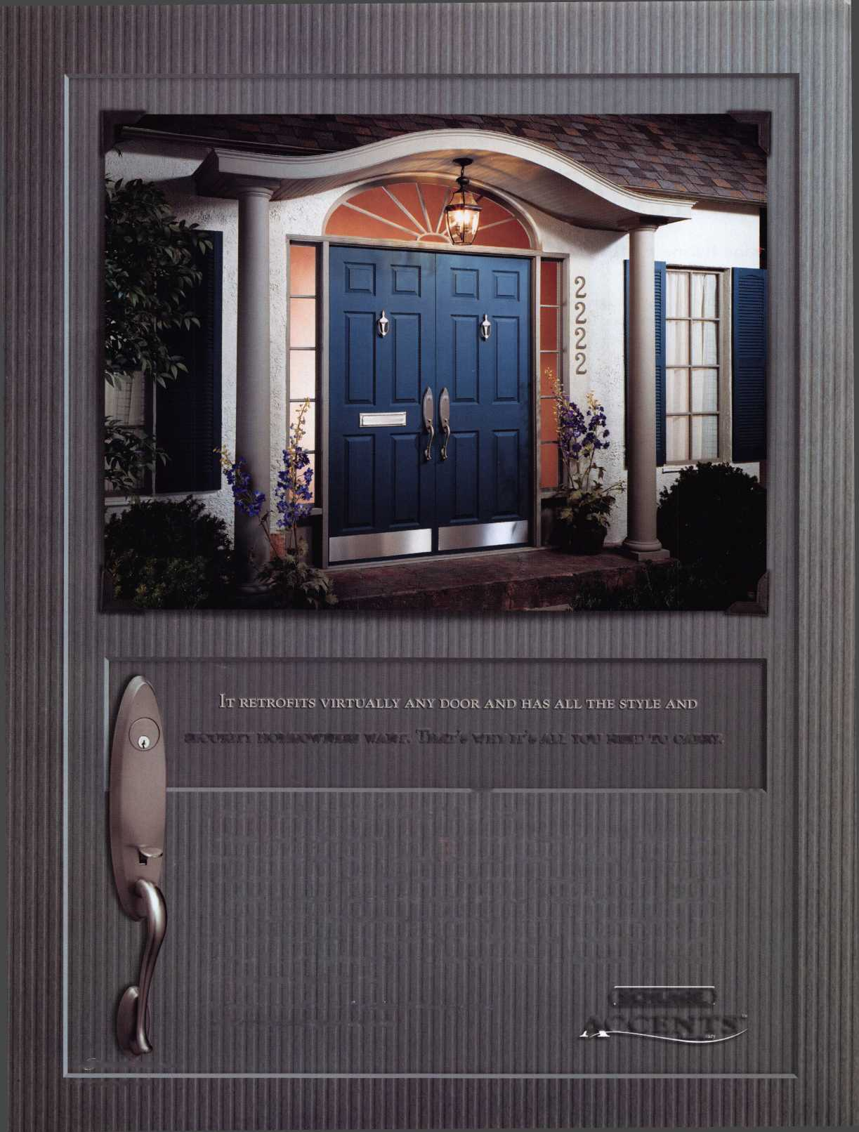

Installing A Door  
Closer on a  
Security Gate

By: Gordon Racine, CML

I have noticed that the trend lately is to install locking gate systems at the  
exterior of many commercial buildings. The biggest problem is keeping these  
doors closed! Most of these installations don't address installing door closers  
or closing springs.

Barry Meyer, CPL a locksmith friend in Casde Rock, Colorado has devel-  
oped an easy way to use standard door closers in a non-traditional way to  
control these gates. Most current door closers are now using fluids that are  
resistant to changes in consistency due to weather conditions. This allows for  
this type of exterior installation.

Picture #1 Shows the gate that we will be installing the closer on

Picture #2 Barry is preparing to mount a door closer drop plate on the gate  
post

Picture #3 & #4 show mounting and leveling the plate

Picture #5 We have now installed the closer body on the drop plate

Picture #6 The arm shoe is now being attached to the gate

Picture #7 & #8 The arm is attached to the closer and only adjustment is  
left to be done.

I noticed that the biggest issue with this type of installation is you need to  
pressure the closer to near to its max pressure to get adequate closing  
strength. All in all, this is a quick way to control the door and allow the  
access control systems to operate as designed.

Pictures #9 # 10 #11 are pictures of the completed installation and  
Pictures #12#13#l4areofa gate closer he had installed previously. Notice  
the post the customer installed to protect the arm of the closer.

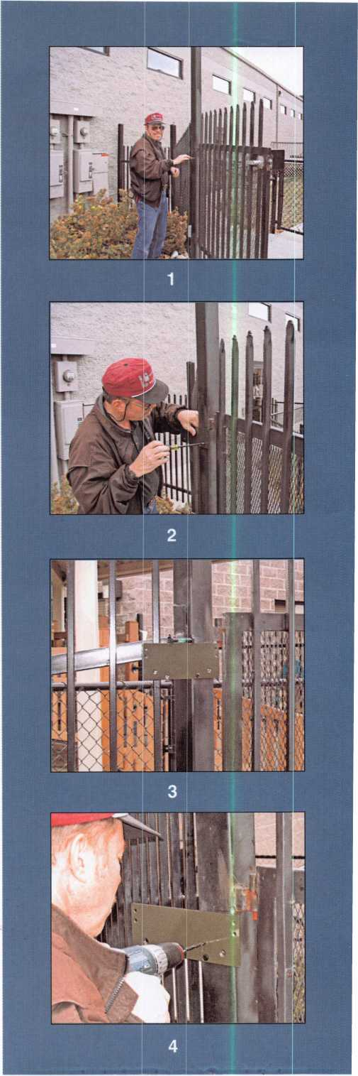

Keynotes • December 2005

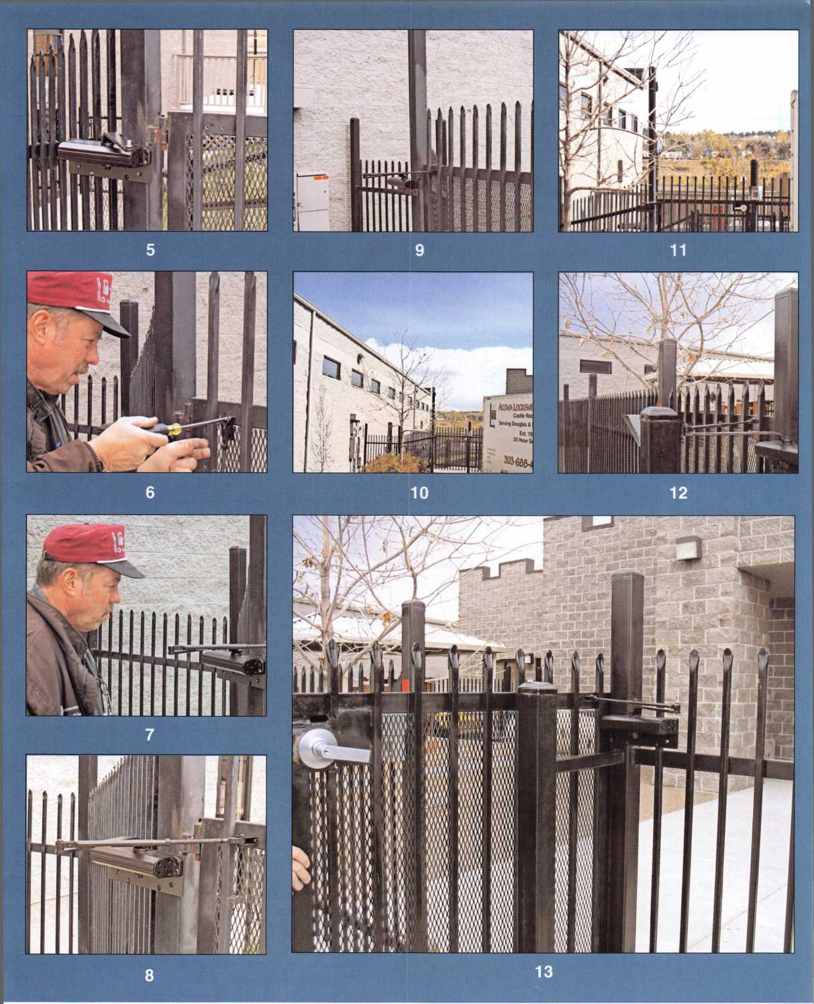

Keynotes • December 2005



American Lock

Door Lock Compatible Cylinders

By: Billy B. Edwards Jr., CML

American Lock has offered door lock

cylinder, SFIC and LFIC compatible padlocks for many years but until now has not offered a variety of the cylinders inside the padlocks. In conjunction with the availability of the new EDGE™ Key Control cylinders we are now offering a wide vari­ety of cylinders and cores with broad keyway compatibility.

These cylinders and cores may be ordered installed in the pad­lock, or you can order them by themselves.

Some of the KIK cylinder keyways are composites but all may be keyed to original manufacturer bitting specifications. In fact, if you order them keyed, we will supply them with keys that match the original manufacturer specs.

In fact, if you have a bitting list for an existing MK system with one of these keyways, we can accomplish the master keying for you at our factory. That is useful when your customers want a large quantity and you don’t have to dedicate shop time to do the keying. It is a good idea to tell us the bitting depths used in the system for all Sargent, Corbin Russwin and Yale keyways as there have been different options for each of them through the years.

To order cylinders only, the following diagram can be used to construct the part number of the exact cylinder you want.

Adding that part number to a door lock cylinder compatible pad­lock will cause it to be installed in the padlock.

|  |  |
| --- | --- |
| Keyway | Description |
| D2G0WP*** | American Lock® Edge™ Key Control |
| DIO | Arrow® K5, K6, L6A |
| D01 | Corbin® 59A1-A2 |
| D29 | Corbin® 60 |
| D07 | Corbin®*Russwin® L4 |
| D32* | Dexte^Master® 67 (composite) |
| D14 | Falcon® 1573,1577 (comp. E-R) |
| D02* | Harloc® SE-1 (composite) |
| D12* | Kwikset® (composite) |
| D08 | Lockwood® |
| D02* | Lori® L200 |
| D80‘ | Lori® Locksmith 80 |
| D90** | Loricentric® 90 |
| Dll | Russwin® 981/852 |
| D30 | Russwin® D1 |
| D3S | Sargent® LA-LC (composite) |
| D70 | Sargent® RA-RC (composite) |
| D02 | Sargent® S |
| D02 | Sargent® U |
| D04 | Schlage® C |
| D34 | Schlage® E |
| D28 | Schlage® P (accepts C-L) |
| D27* | Segal® 9.265 |
| D13* | Weiser® (composite) |
| D33* | Weslock® |
| D03 | Yale® 8 |
| D15 | Yale® GA |

‘Exclusively available as 5-pin cylinder “Exclusively available as 6-pin cylinder “‘Exclusively available as 4 or 6-pin cylinder

Keynotes • December 2005

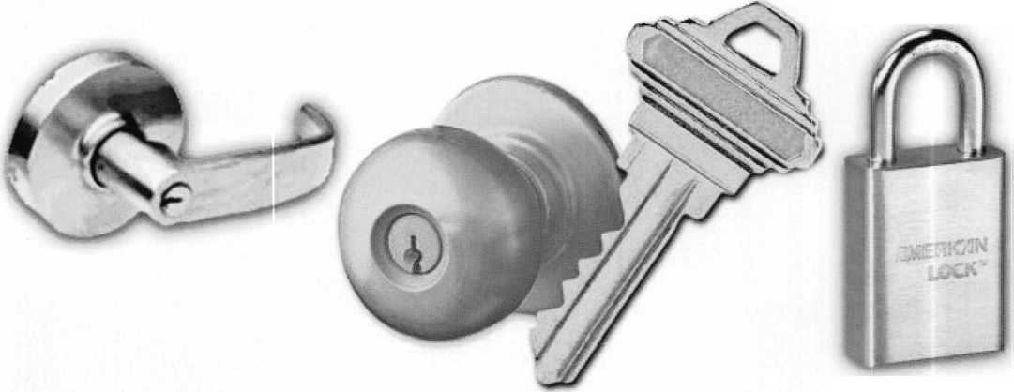

AD045KD

Door Hardware Cylinder

Keying Specification

Keyway

|  |  |  |  |
| --- | --- | --- | --- |
| Manufacturer's Brand Name | | Russwin D1 | 30 |
| Arrow | 10 | Sargent LA-LC* | 36 |
| Corbin 59A1-2 | 01 | Sargent RA-RC* | 70 |
| Corbin 60 | 29 | Sargent S* | 02 |
| Corbin Russwin L4 | 07 | Sargent U* | 02 |
| Falcon 1573,1577* | 14 | Schlage C | 04 |
| Harloc SE-1* | 02 | Schlage E | 34 |
| Kwikset* | 12 | Schlage P | 28 |
| Lockwood | 08 | Segal 9.265 | 27 |
| Lori L200* | 02 | Weiser* | 13 |
| Lori Locksmith 80 | 80 | Weslock | 33 |
| Loricentric 90 | 90 | Yale 8 | 03 |
| Master/Dexter 67* | 32 | Yale GA | 15 |
| Russwin 981/852 | 11 | American Lock Edge™ | 200WP |

Key Control System (Available with 4 or 6 pins only)

KD - Keyed Different

KA - Keyed Alike

KZ - Zero Bitted

KDMK - KD Master Keyed

KAMK - KA Masker keyed

UN - Uncombinated**

Number of pins

1. - four"1*
2. - five 6- six

* Indicates a composite keyway ** Exclusively available for Edge™ Key Control System only

There is a special component that allows the door lock cylinder to operate the padlock locking mechanism called a driver. We also offer a number of drivers that allow use of different door lock cylinders in our padlocks.

In the table below you can see the various drivers available and an indication of what brand cylinder they should adapt to our padlocks.

|  |  |  |  |
| --- | --- | --- | --- |
|  | Part Number | Used in Locks | Use Notes |
|  | ADRSCH6 | A3600, A3700, A3800 | Schlage or any 100% copy |
| ® -f. | ADRMED6 | A3600, A3700, A3800 | Medeco 20 series |
|  | ADRLOR30 | A3600, A3700, A3800 | Lori 1530 |
| g; , | ADRL0R39 | A3600, A3700, A3800 | Lori 1539 |
|  | ADRVAR36 | A3600, A3700, A3800 | Assortment of Schlage, Medeco and Lori 1539 |

Keynotes • December 2005



As a part of adding door lock cylinders to our product line, we are also adding SFIC 6 and 7 pin cores in either of two finishes, (US3 or US26D), and any of the keyways listed here.

We have the capability to supply these cylinders keyed or uncombinated.

We offer A2 or A4 bitting compatibility but will not attempt to match your A3 specs. If you have an existing key system and can supply the bitting information for the keys, (including the Control Key), we can key the cores to match the existing system.

If you have an existing system and want expansion under those same MK s and Control, send us a bitting list of what you have now and we can recreate the keying system and expand it to the full capacity it was originally designed to meet. We’ll be happy to supply you with a copy of the system upon written request.

There is another diagram below that can be used to order exactly the core you want. We offer the SFIC in a 6 pin length and a 7 pin length to match your current core configuration.

|  |  |  |  |  |  |
| --- | --- | --- | --- | --- | --- |
| CA604KD | | | | | |
| Interchangeable Com _ . |  |  |  |  | Keying Specification |
| Keywav/Kev Section | |  |  |  | KD - Keyed Different |
|  | | |  |  | KA - Keyed Alike |
| Manufacturers Brand Name | | |  |  | UN - Uncombinated |
| A - Best A Keyway  B - Best B Keyway | | |  |  | KDMK - KD Master Keyed |
| C - Best C Keyway | | |  |  | KAMK - KA Master keyed |
| D - Best D Keyway | | |  |  |  |
| E - Best E Keyway | | |  |  | Finish |
| F - Best F Keyway | | |  |  |  |
| G - Best G Keyway | | |  |  | 04 - Satin Brass |
| H - Best H Keyway | | |  |  | 26D - Satin Chrome |
| J - Best J Keyway | | |  |  |  |
| K - Best K Keyway | | |  |  |  |
| L - Best L Keyway | | | — Number of Dins | | |
| M - Best M Keyway | | |  |  |  |
| Q - Best Q Keyway | | | 6 - six | |  |
| W - Arrow 1C Keyway | | |  | |  |
| X - Arrow ID Keyway | | | f - seven | | |
| Y - Generic Keyway | | |  |  |  |

Adding the part number of the SFIC from above to any of our 3100, 3200 or 3300 Series locks will allow you to order the core inside the padlock body.

Both types of locks can be ordered just as in the past if you prefer ordering cylinders or cores separately but the new keying options can make getting what your customer needs a little simpler. For more information, contact your American Lock Distributor.

|  |  |
| --- | --- |
| Key way | Description |
| CY | Generic  SFIC Keyway |
| CA | Best® Lock  A Keyway |
| CB | Best® Lock  B Keyway |
| CC | Best® Lock  C Keyway |
| CD | Best® Lock  D Keyway |
| CE | Best® Lock  E Keyway |
| CF | Best® Lock  F Keyway |
| CG | Best® Lock  G Keyway |
| CH | Best® Lock  H Keyway |
| CJ | Best® Lock  J Keyway |
| CK | Best® Lock  K Keyway |
| CL | Best® Lock  L Keyway |
| CM | Best® Lock  M K ey way |
| CQ | Best® Lock  Q Keyway |
| CW | Arrow® Lock  1C Keyway |
| CX | Arrow® Lock  ID Keyway |

Note: Padlock bodies will also accept small format cores of the following OEM brands:

Best* Best* PKSf Arrow*, Falcorf, Kaba* Peaks, KSP*& Lori*

**8**

Keynotes • December 2005

£verV

bodV Wi>nts it

**FKI**

SECURITY GROUP

**(gfg) Sec**urit**y & Saf**e**t**y

**.. You** MIGHT TAKE

IT HOME!

One Lucky Member Attendee at ALOA  
2006 is going home with this gorgeous  
mint-condition 1956 Ford Thunderbird.

A ticket will be given to each ALOA  
Member who registers and attends the  
show. Someone has to win it, and it  
might as well be YOU!

(Must be present to win. Exhibitors,  
Employees. Family Members of Employees, and  
nonmembers are not eligible for this door prize.)

SECURITY PRODUCTS

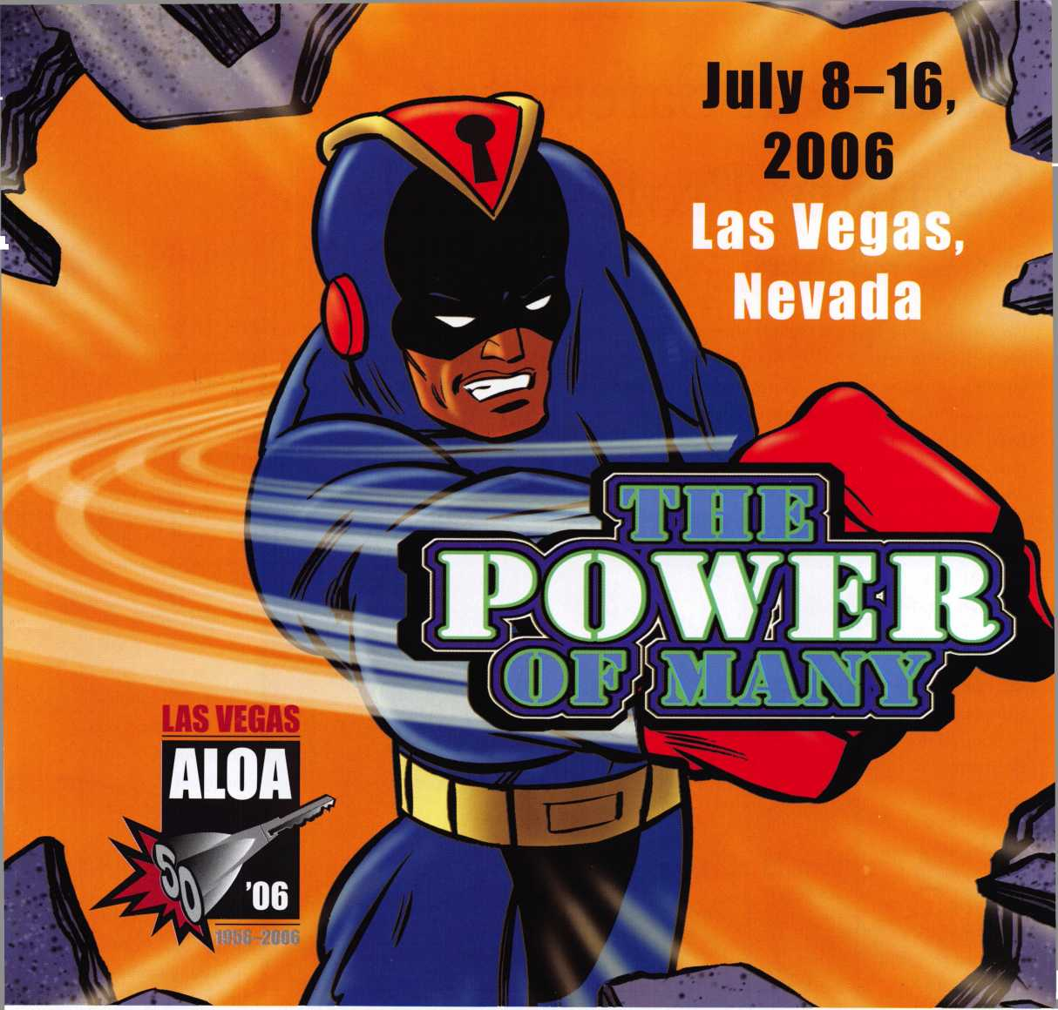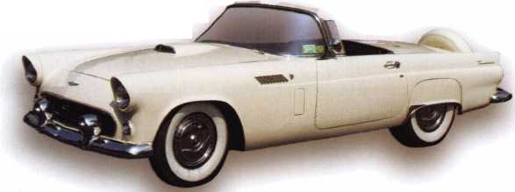

Electrical Safety for Security Professionals

By: Greg Perry, CML, CPS

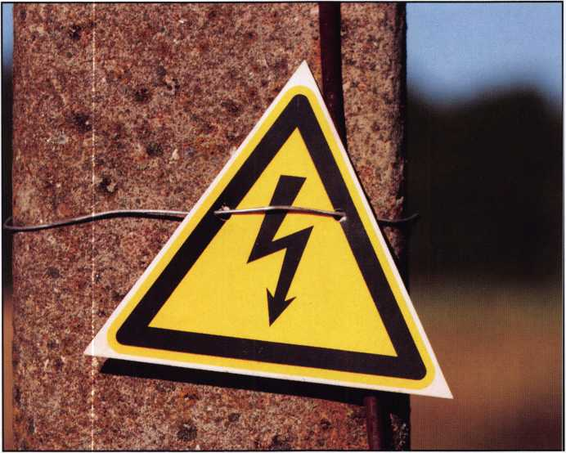

Do you like going home at night in the same shape as you  
left in the morning? Most of you might think this is a silly  
question, of course you do! Who wouldn’t? The answer to  
this question is those who choose to not work safely.  
Dangers are lurking everywhere all day long. From the  
moment you wake up and step out of bed forgetting the

dog is under foot,  
the day is filled  
with hazards. The  
emphasis this  
month is electric  
locks. This article  
is going to address  
some of the haz-  
ards present when  
working around  
electricity,  
although much of  
the information  
can also be used to  
work safely while  
performing general  
locksmith tasks.

Some people claim  
working safely  
costs too much,

actually it can save. How expensive is a trip to the emer-  
gency room for stitches? I know of a case where an electri-  
cian was electrocuted while loosening some cover screws on  
a panel. He was off work for three months and endured  
many more months’ of therapy. His work would not nor-  
mally be considered unsafe. Another cost to consider is  
the requirements your customer may have to perform elec-  
trical or any type of work at their location. We work at a  
mine site that requires all personnel working at their site

have 24 hours of safety training to start and 8 hours per  
year refresher safety training. This is factored into what we  
charge this customer.

Before going any further with safety let’s discuss in simple  
form a few electrical terms. AC stands for Alternating  
Current, DC stands for Direct Current. Electricity is often

compared to water,  
Voltage is compared  
to water pressure  
and Current or  
Amps is similar to  
the number of gal-  
lons of water sup-  
plied. The combi-  
nation of the two is  
the amount of work  
being done or  
Watts. A 60 watt  
light bulb draws or  
uses 1/2 an amp at  
120 volts. Your  
corded drill might  
pull 6 or 7 amps. 2  
to 10 milliamps or  
thousandths of an

amp can cause muscle contraction, 100 milliamps or 1/10  
of an amp can kill you if the flow through your body is  
through your heart. Resistance is like friction it prevents  
or resists the flow of electricity. Electricity wants to flow  
like water down a hill, only electricity wants to flow in DC  
between the positive and negative or in AC from the wire  
to the earth ground. Most of the electric work locksmiths  
perform is low voltage, defined as 12 or 24 volts AC or  
DC at less than 1 amp. In general these voltages are not

Keynotes • December 2005

extremely hazardous. They might cause a tingle or maybe a slight twitch in the muscles. These voltages don’t have enough power to overcome the resistance in our body. If we reduce the resistance by wetting our skin the flow of electricity increases. Most of us have touched a nine-volt battery to our skin without feeling it and then touched it to our tongue to feel a good tingle. This is an example of reducing resistance. Standing in a puddle of water while doing electrical work reduces the resistance to ground.

Normally voltage supplied to houses and small businesses in the US is 240 volts AC which then split at the electrical panel to 120 volts to earth ground. This is typically the voltage we plug into with a transformer although some panels are connected directly with conduit and wire or a plug in cord set. 120 volts can cause injury or death. The first step in working safely is to unplug or turn off the cir­cuit breaker supplying the power to the panel. The next step is to test with a voltage meter for power and then test the meter at a circuit that is powered to make sure the meter is operating properly. If you need to work while the circuits are powered and you do not know the voltage expected then set your meter at the highest setting and work down in range to the appropriate setting.

Many of you sell safety lockout hasps, have you ever used one? Lockout/Tagout are big terms in most factories. What do these terms mean? First all forms of energy are turned off and the switch or ability to turn it back on is locked with a padlock. In addition a tag is added to indi­cate whose lock is attached.

Energy can be electrical, hydraulic, kinetic, mechanical, heat, steam, hazardous gases or combination of any of these. In some cases power may be fed from multiple directions, this is why you must test. IVe rekeyed mortise cylinders in overhead door switches requiring lockout/tagout. The door could be operated from three separate switches. This is also a case where the voltage was 277 volts AC for the controller. Not your common elec­tric lock voltage, if you are uncomfortable dealing with locks in this situation have an electrician remove the lock for you to rekey.

Ladders are a big part of our work. Often wiring is run in attics or above drop ceilings. Fiberglass ladders although

more expensive are the best choice. Aluminum ladders are not acceptable for electrical work because they will conduct electricity. Wood ladders, although considered safe for electrical work are not allowed in most industrial plants because they splinter, deteriorate and in general are not as rigid. Quality fiberglass ladders are both electrically non- conductive and do not splinter or deteriorate as fast as wood ladders. Proper ladder use requires care. Do not extend your body to either side of the ladder, if you need to reach further move the ladder closer. Ladders have a maximum working height, do not exceed this, or climb to the top of a stepladder. Extension ladders must be placed one foot away from the wall for every four foot of height. The bottom can be tied to the wall with a rope if condi­tions dictate it. Depending on where you are working you may be required to tie off anytime your feet are more than six feet above the base of the ladder, or even on some walk­ways or scaffolding.

Safety equipment should always be used where appropri­ate, the standard stuff like safety glasses, hardhats, and steel toe safety shoes are required in almost all factories and con­struction sites. Other equipment you might not think about is: hearing protection for use with most power tools or in noisy environments, respirators for dust, knee pads if you need to kneel and appropriate welding protection. A couple of items many of us might forget are safety cones and barrier tape to prevent others from entering our work area, possibly creating a hazard for both the worker and visitor. Some applications might require a second employ­ee to act as a watch. Don’t forget to price this into your bid or bill the customer for the extras.

The primary cause of all accidents is unsafe work habits. Taking shortcuts, overextending, forgetting safety glasses, and using the wrong tool or just plain ignoring safety rules can all lead to injuries. How many of you turn your key machine off to insert or remove a key blank? I’ve seen injuries to the back of the knuckle from a cutter. When working around electricity or machinery accidents can hap­pen in a split second. Remember electricity is invisible and deadly. I make a point of working safely so at the end of the day I’m home and not in the hospital or worse. I hope you will too!

Keynotes • December 2005



Requirements to Maintain PRP Certification/ALOA Membership

Summary

Before reading the new requirements to maintain PRP cer­tification and/or ALOA membership, it is important to understand a few basic facts.

First, anyone who has an ALOA PRP Certification (RL, CRL, CPL, CML) as of January 1st, 2006 has that certifi­cation for life. It will not need to be renewed.

However, to maintain eligibility for membership in ALOA, a recertification may be required. The requirements to maintain membership are the same as the maintenance of PRP Certifications required for all who receive that desig­nation after the first of January 2006. Members, however, are “grandfathered” according to the exemptions listed in the bylaws change passed last June. The “grandfathering” was explained in the last issue of Keynotes.

People who live outside of the United States and its territo­ries are exempt from the requirement to have and maintain a professional security designation as a requirement for ALOA membership. They are, however, required to re-cer- tify to maintain a PRP designation earned after the first of January, 2006.

Active Members will be required to obtain and maintain a security related professional designation. The designation RL, (Registered Locksmith), is and has been for many years a part of the ALOA PRP. Obtaining the “RL” desig­nation does not require a test. Therefore a member can obtain and maintain a security professional designation without ever passing a test. In addition to the ALOA PRP designations, the following designations have already been approved:

* Safe and Vault Technicians Association - Certified Professional Safetech (CPS) and Certified Master Safe Technician (CMST)
* ASIS International — Certified Protection Professional (CPP) and Physical Security Professional (PSP)
* Door and Hardware Institute — Architectural Hardware Consultant (AHC), Certified Door Consultants (CDC), Electrified Hardware Consultants (EHC), Architectural Openings Consultants (AOC)
* International Association of Investigative Locksmiths - Certified Forensic Locksmith (CFL)
* National Burglar and Fire Alarm .Association - Certified Alarm Technician Level 1 (CATl)
* Institutional Locksmith Association — Certified Institutional Locksmith (CIL)

If a member has a designation that he feels should qualify for the purpose of maintaining membership, he may request that the ALOA Education Department (AED) con­sider this designation for inclusion. Generally the require­ments are that they be administered by a recognized national or international organization and there is a recerti­fication requirement.

The classes, seminars and other educational events listed in the following document do not have to be offered by ALOA. In general, classes must be of the same general quality and length of time to be recognized. Therefore most classes offered by other security organizations such as ASIS, DHI, NBFAA and others will usually be acceptable. Classes offered by private schools such as Fox Valley Technical College, Lockmasters, MBA, North Bennet Street School and others may also be acceptable. Once a class has been approved, it will be listed by the AED as “approved”. Any class that a member has taken or wishes to take may be submitted for approval consideration.

**22**

Keynotes • December 2005

ALOA PRP Re-certification

The security industry is in a constant state of evolution. To protect the integrity and advance the professionalism of the CRL, CPL and CML designations, the ALOA Board of Directors through the ALOA Education Department (AED) has mandated that all holders of ALOA certifica­tions achieved after January 1, 2006 pursue professional development and continuing education in order to main­tain proficiency and credibility.

Those that achieved their designations prior to January 1, 2006 are exempt from the AED requirement for recertifi­cation; however they will have to comply with the ALOA Active membership requirement to have and maintain an ALOA recognized certification.

Recertification requirements established by the AED involve obtaining a specified number of credits (16 pts within three years), in areas such as education, training, teaching,writing and volunteer leadership in locksmith/security and business management associations. The AED will review and revise activities approved for credit as appropriate.

Recertification activity reports must be submitted to the ALOA Education Department every three years for holders of the CRL, CPL and CML designations. All certification holders may submit credit-reporting forms with accompa­nying documentation (copies of certificates, newsletter list­ings, etc.) at any time during their terms, and are encour­aged to do so, on an annual basis.

The re-certification fee is $60.00 for members and $215.00 for non-members, payable every three years. ALOA will send an invoice after the credit requirement is met. All checks must be made payable to ALOA in U.S. dollars and must be drawn on a U.S. bank. The fee is sub­ject to change.

ALOA PRP Re-certification Activities Schedule Summary

16 total points are required within a three-year term.

NOTE 1: For CRTs and CPUs — advancement to the next level of certification resets the certification term to three years from the date that the most recent certification level is achieved.

NOTE 2: Rules for writing exam questions must be followed. See 3.4

NOTE 3: Activities submitted for Re-certification must not be within the scope of employment and/or performed as a require­ment of employment.

NOTE 4: Written documentation (i.e. copies of certificates, registrations, articles etc.) is required for all activities, except those certified by ALOA.

To make the recertification process as fair as possible the AED has provided ALOA members with the opportunity to achieve recertification points from seven major sources which are; Association Memberships, Education program participation, Instruction/Presentations, Publications, Volunteer Service, Public Service and Other Accomplishments.

The following is summary of how points are accumulated in these areas.

Association Memberships — You can accumulate points by being a member of

* ALOA,
* SAVTA,
* An ALOA Chapter or
* An ALOA Affiliate association.

Education participation - You can accumulate points by:

* Attending classes at any nationally recognized security association conference (such as ASIS,

DHI, ILA, IAIL, etc.), by

* Attending ALOA Continuing Education (ACE) classes and/or the ALOA Security Expo,
* Attending SAVTA classes and/or exhibits,
* Attending regional or local association classes and/or exhibits,
* Successful completion of a written exam for lock­smith/security related self-study program that is accredited or otherwise recognized, (this may include ACE after class PRP exams, Internet/dis- tance learning, and CD-ROM or other self-study programs)
* Participation in, or attendance at, a locksmith/security related, educational session - including Internet/distance learning and CD- ROM or other self-study program
* Sitting for a PRP/STPRP exam.

Instruction, speeches or other presentations. - You can

accumulate points by;

* Being the principal instructor/speaker in a security related course at an accredited college or university of at least 3 semester credit hours

**23**

Keynotes • December 2005

* Instructing an ALOA ACE class
* Participating as an assistant instructor for an ALOA ACE class
* Participating as an instructor, speaker or panelist at any security related educational program of at least 3 hours
* Preparing usable PRP/STPRP exam questions in the proper format and from current references.

Publications - You can accumulate points by;

* Authoring an approved security-related book
* Contributing to a book on security-related topics
* Authoring a security-related article in a recognized national periodical
* Contributing to recognized security-related national periodicals (i.e. submission of trade tips)
* Writing a book review published in a security- related national periodical

Volunteer Service - You can accumulate points by;

* Serving as a committee member of a local or regional security organization
* Serving as an elected President/Chair, Vice- President/Chair, Secretary, Treasurer or Newsletter Editor on the local level of a chartered security organization
* Serving as a board member or officer of the ALOA Scholarship Foundation, SAVTA Board of Directors, ALOA Board of Directors or any char­tered national security organization or association

such as ASIS, DHI, ILA or IAIL.

Public Service — You can accumulate points by providing security-related activities that are performed pro bono for a charitable, religious, governmental or community entity.

Examples include but are not limited to:

* security audits of a public or private school build­ing
* security or life safety surveys for a church, syna­gogue or other place of worship
* evaluation of life safety or security issues for a charitable agency

Other Accomplishments - You can accumulate points by participating in special activities related to professional development in security or business management.

Examples include but are not limited to:

* Proctoring a PRP examination
* Participating in PRP/STPRP exam category devel­opment
* Participating in an ACE Instructor Class evalua­tion
* Participation in ACE curriculum development
* Participation in ACE class development

This has been a summary of the ALOA PRP recertification program. The following is a detailed chart that specifies how points are accumulated.

|  |  |
| --- | --- |
| 43rd ANNUAL CONVENTION & TRADE SHOW | |
| The 2006 Texas Locksmith Conference and Trade Show | |
| Doral Tesoro Hotel in Ft. Worth, Texas | |
| February' | 7-12, 2006 |
| • FREE CLINICS | ■ ELECTION & INSTALLATION OF NEW OFFICERS |
| ■ FREE SEMINARS | ■ PRODUCT EXHIBIT |
| ■ GENERAL MEMBERSHIP MEETING | • SCHOLARSHIP RAFFLE ■ BANQUET DINNER |
| FOR CONFERENCE OR TRADE SHOW INFO CONTACT:  Troy Maynard, Secretary  Texas Locksmiths Association  RO. Box 342  Dripping Springs, TX 78620  Phone: 512-264-0279 ■ Fax: 512-264-3060  Email: [sec@texaslocksmiths.org](mailto:sec@texaslocksmiths.org) | FOR HOTEL RESERVATIONS CONTACT:  1-866-33-D0RAL  Doral Tesoro Hotel & Golf Club  3300 Championship Parkway  Ft. Worth, TX 76177  Phone: 817-961-0800 • Fax: 817-961-0900 |

ALOA PRP Re-certification Activities Schedule

16 total points required in three-year term

NOTE 1: For CRTs and CPUs — advancement to the next level of certification resets the certification term to three years from the date that the most recent certification level is achieved.

NOTE 2: Rules for writing exam questions must be followed. See 3.4

NOTE 3: Activities submitted for Re-certification must not be within the scope of employment and/or performed as a require­ment of employment.

NOTE 4: Written documentation (i.e. copies of certificates, registrations, articles etc.) is requiredfor all activities.

Activity

|  |  |  |
| --- | --- | --- |
| 1 . Membership | Points Per year | Limit per term |
| 1.1 Active Membership in ALOA | 2 | 6 |
| 1.2 Active Membership in SAVTA, a local ALOA chapter or ALOA Affiliate association. | 1 per each | 3 per each |

|  |  |  |
| --- | --- | --- |
| 2. Educational Programs and Courses | Points Per year | Limit per term |
| 2.1 Attendance of three or more days at a recognized security organization's annual or other major conference. | 2 per each | unlimited |
| 2.2 Completion of an ACE certified class | 1 per day | unlimited |
| 2.3 Successful completion of a security or business management-related 3 credit course at an accredited college or university — including Internet/distance learning, and CD-ROM or other self-study program that results in college or university credit. | 4 | unlimited |
| 2.4 Successful completion of a written exam for locksmith/security related self-study program that is accredited or otherwise recognized; and has duration of at least 8 hours with formal curricula related to core security skills. May include ACE after class PRP exams, Internet/distance learning, and CD-ROM or other self-study program. | 1 each | unlimited |
| 2.5 Participation in, or attendance at, a locksmith/security related, educational session of eight hours - including Internet/distance learning and CD-ROM or other self-study program. | 1 each | unlimited |
| 2.6 Participation in, or attendance at, a locksmith/security related, educational session of four hours. | .5 each | unlimited |
| 2.7 Attendance at any locksmith/security-related exhibition | .5 each | unlimited |
| 2.8 Sitting for a PRP/STPRP exam | .5 each | unlimited |

|  |  |  |
| --- | --- | --- |
| 3. Instruction, Speeches and Other Presentations | Points Per year Limit per term | |
| 3.1 Principal instructor/speaker in a security related course at an accredited college or university of at least 13 semester credit, hours. | 5 | unlimited |
| 3.2 Principal instructor for an ALOA ACE class per 8 hours | 4 | unlimited |
| 3.2 Appearance as an instructor, speaker or panelist at a security related educational program of at least 3 hours | 1 each | unlimited |
| 3.4 Preparation of usable PRP/STPRP exam questions in the proper format and from current references (1 for each  5 questions submitted for evaluation before September 1 of each year). Required revisions must be approved before December 1st for credit to be given. (PRP/STPRP Exam Item Writing Instructions document available from AED) | 1 each set of five | unlimited |

**25**

Keynotes • December 2005

Activity

|  |  |  |
| --- | --- | --- |
| 4. Publications * | Points Per year | Limit per term |
| 4.1 Authoring an approved Security-related book. | 6 | unlimited |
| 4.2 Contribution to a book on security-related topics. | 3 | unlimited |
| 4.3 Authoring a Security-related article in a recognized periodical. | 3 | unlimited |
| 4.4 Contribution (i.e. trade tips) to a national recognized periodical | .5 each | unlimited |
| 4.5 Writing a book review published in recognized periodical. | 1 each | unlimited |

|  |  |  |
| --- | --- | --- |
| 5. Volunteer service in a chartered security organization | Points Per year Limit per term | |
| 5.1 Each year served as an officer (President or Secretary) of the ALOA Board of Directors. | 2 | 6 |
| 5.2 Each year served as a member of the ALOA Board of Directors, President of SAVTA or President of the ALOA Scholarship Foundation. | l | 3 |
| 5.3 Each year served as a board member of: the ALOA Scholarship Foundation, SAVTA Board of Directors or Board of a chartered national security organization or association. | l | 3 |
| 5.6 Each year served as a Council member, Council committee chair, or Chair of the Host Committee for an annu­al or other major conference of a security-related organization. | l | 3 |
| 5.8 Each year served as an elected President/Chair, Vice-President/Chair, Secretary, Treasurer or Newsletter  Editor on the local level of a chartered security organization | l | 3 |
| 5.9 Each year served as a member of the Host Committee for an annual or other major conference of a security- related organization. | l | 3 |
| 5.10 Each year served as a national Council committee member or an appointed officer or committee chair on the local level of a chartered security organization, (including CML Representatives) | l | 3 |
| 5.11 Each year served as a committee member of a local or regional security organization. | l | 3 |

|  |  |  |
| --- | --- | --- |
| 6. Public Service | Points Per year Limit per term | |
| Security-related activities that are performed pro bono for a charitable, religious, governmental or community entity. Examples are; security audits of a public or private school building, security or life safety surveys for a church or synagogue, evaluation of life safety or security issues for a charitable agency. AED will determine points to be awarded based on scope of activity, value to recipient, accomplishments vis-a-vis objectives and time spent. | At discretion of AED | (1-5 points) |

|  |  |  |
| --- | --- | --- |
| 7. Other Accomplishments | Points Per year Limit per term | |
| Special activities related to professional development in security or business management. Examples include: proc- toring a PRP examination, participating in PRP/STPRP exam category development, participating in an ACE  Instructor Class evaluation, participation in ACE curriculum development, participation in ACE class development. AED will determine points to be awarded based on scope of activity and time spent.) | At discretion of AED | (1-5 points) |

*Any other kind of publication may be submitted for eligibility review to the ALOA Board of Certification.



Keynotes • December 2005

**Visit**

**[www.kaba-ilco.com/vanpromo](http://www.kaba-ilco.com/vanpromo)  
for all the details!**

Sweepstakes is open to all professional Locksmiths & Security personnel, located in the 50 U.S., die District of Columbia & Canada (except for Quebec), who have an account with an authorized Mco Products Distributor, who are eligible to make purchases of qualifying lico parts from authorized llco Distributor's & who are 21 years of age or* older' as of 5/24/06. Void in Quebec & where prohibited by law. No purchase necessary. For die Official Rules & for an Official Bitty Form, log on to [www.kaba-ilco.com/vanprorno](http://www.kaba-ilco.com/vanprorno), or see your llco Products Distributor, Mail entries to: lico “You Could Win A Trip To Vegas & Ultimate Lockshop Package” Sweepstakes, P.O. Box 222510, Hollywood, FL 33022-2510. Entries must be postmarked by 5/17/06 and reed by 5/24/06.

A Member of the KABA Group [www.kaba-ilco.com](http://www.kaba-ilco.com)

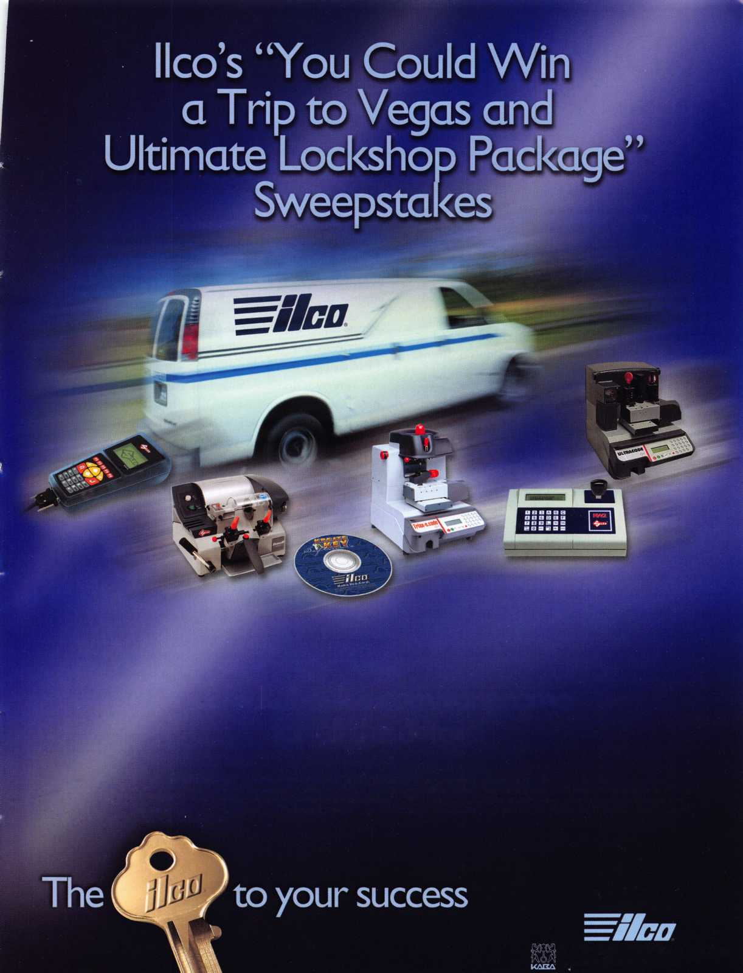

A Day in Court

By: Eric Costley, CPL

If someone ever asks, “Would you swear to that in a court of law?”, say, “no”. Of course, if you are properly compen­sated for your time and expert testimony, why not? I guess that IVe been fortunate to avoid such a situation for over 25 years, but the great gavel of fate finally came beating on my door.

I returned to the shop one afternoon after a busy day, and noticed an envelope in my “inbox”. It was marked “personal and confidential” and had my name hand-writ- ten on the front. I didn’t recognize the handwriting but I knew that we had recently picked up some documents from the accountant, so I thought that perhaps it was something dealing with insurance, taxes, or some similar thing. Other than that, the silence in the shop made me wonder if it was the dreaded “pink slip”, but I doubted it. I ripped the envelope open and was shocked to find a sub­poena to appear in court, and a check for a paltry amount of money that didn’t even cover gas and parking, much less the time involved.

Getting a subpoena and a check in the same envelope is somewhat like getting paid for a slap in the face. I was angry, and confused. The names involved in the case didn’t ring any bells and the check said “witness fee” in the memo section. I knew I hadn’t done anything wrong, but I was baffled regarding who this was, what job it concerned, and why on earth someone would call me as a witness! I had a little pow-wow with my employers and we all racked our brains trying to figure it out. It only took a few minutes to sort out a very vague and fuzzy picture.

Most of my days are spent primarily in the field, running from job to job. It is a rare day that I spend more than an hour inside the shop, and that’s total time anot all in one stop). Evidently, there had been a few calls for me from a private investigator but obviously he must not have been a very good one, since he couldn’t find out where I live or track down a phone number where he could actually speak to me.

In this particular instance, it was probably advantageous that I live in a different county from the shop. We only use cell phones in the house. Therefore, there is no “hard­wired” phone.

There might have been a very short mention of these calls at a morning meeting, but we all pretty much figured that it would be a waste of time, so the topic immediately g ot shelved.

I guess what puzzled me most was what I was supposed to testify to! Our fuzzy outline came down to the fact that I had changed the combination to a safe in a home where the owner was deceased. Since jobs that are paid at the time of service get entered into the computer differently than jobs with an account, tracking down the name to gather more information would’ve been a very long, tedious process, and we didn’t want to waste the time.

I was also baffled that I wasn’t handed the subpoena in person and that no one had contacted me since to discuss the case. Although it wasn’t much, I decided to cash the check from the lawyer and stop for some groceries on the way home.

When court day finally came, I had spent many s leepless nights thinking about what I would say in court.

I assumed that the questions would revolve around how difficult it would be for someone to surreptitiously gain entry to a safe without a combination, if that process would leave evidence on the exterior of the safe door, and so forth. I had about a week to spend without sleep, so I pretty much had my “patter down pat”. I had anticipated, practiced, and honed virtually every scenario that I could conceive of. I had brushed up on my technical jargon, and intended to “wow” whomever might be present with my vast knowledge and experience in safework. I was prepared, despite my distaste of thewhole situation and my contempt of the paltry witness fee to be the expert witness that I knew I could be.

**28**

Keynotes • December 2005

The great gavel of fate  
finally came beating on

my

oor

waited. I didn’t realize that I should’ve brought some trade magazines or puzzle books. I exited the building more than once to grab a few puffs off of a ciga­rette and to pump more coins into the parking meter.



When court day came, the “zero hour”  
was 1:00 pm. Oh, did I mention that  
this is not the county in which the  
shop is located? Not only do I live in a  
different county, the court was in a  
county beyond that. From the shop, it’s  
about 35 miles. From where I live, it’s  
more like 70miles. Of course, at this  
time, that was not an issue. I was at  
work, and we had managed to schedule  
a job for the same day at a museum  
that was only a few miles from the  
courthouse.

As I was headed to court, I got a call on

the cell phone to inform me that my services in court  
would not be needed until 2:30 pm. I headed for the  
museum, convinced that I could finish the job and proceed  
to the courtroom. I was correct.

I pulled into a parking space outside of the courthouse  
about 15 minutes early, and that gave me time to remove  
all the accouterments of the profession, including my tool  
belt, cell phone, pager, all the change from my pocket, and  
anything else metal that might go “beep” as I walked  
through the metal detector. (We installed high security  
cylinders at this courthouse about two years ago, so I knew  
pretty much what I was in for.) Unfortunately, the elderly  
couple ahead of me in line wasn’t quite as prepared. The  
security guard removed a nail file and small pair of scissors  
from the ladies purse, and assured the gentleman that the  
metal detector would not do anything to trigger the  
defribulator that was permanently imbedded in his chest.

I waltzed though without a blip.

Officially, I’m off the clock at 4:30 pm, but it was nearly 5:30 when the courtroom closed down for the night. The former customer that had summoned me here emerged from the courtroom, apologized, and said that I was next, but I would have to come back later.

At this point, all that I said was that he should contact my employers. I was fuming over the waste of time, as well as the fact that I would arrive home more than two hours late. The prospect of coming back to court was appalling but I didn’t want to be held in contempt, which would mean a fifty-dollar fine. (Besides, I’d already wasted 3 hours of time for nothing. I was curious to see what the outcome of this would be.)

A few days later, another letter appeared for me. The date was set, and the time was 9:30 am. Although we didn’t have any jobs in the area that day, at least it was scheduled early and I knew I was next in line to testify. I left the house around 7:40 a.m. so that I would arrive on time.

Arriving outside the courtroom in the waiting area, I found a local jeweler, a priest, a police officer, and myself as well as two or three others whose professions I couldn’t discern. (Sounds like a set up for a joke, doesn’t it?) I had done a few jobs for the jeweler, so we chatted a bit as I

It was interesting that the lawyer actually spoke to me at this point. Fie asked me if I recalled the job, and I remarked, “well, not really.se The customer produced the original receipt from the job at this time, and sure enough, it was my job! As it turns out, the job had occurred over



Keynotes • December 2005

18 months prior to the court date and was a simple job to change the combination on a safe. The safe was a Mosler safe that was equipped with an S&G 6720. The informa­tion sparked my memory slightly, but not much.

As a rule, I normally run between 6 and 8 outside jobs a day. In any given day, two or three of these jobs might involve safes. In the course of any day, I might interact with 30 or more people, most of whom are quickly forgot­ten unless I see them frequently, or unless something about the job stands out. I didn’t have time to do a lot of remi­niscing, so I took what little I remembered and headed into the courtroom.

After everyone was seated and waiting, there was a long pregnant pause. During most of this time, my stomach growled loudly. Another 13 minutes elapsed until the judge appeared, and the command “all rise” was sounded.

I was glad that this might come to an end soon, and I could get back to doing what I do best: working on locks.

By the way, have you ever noticed that “important people” deliberately make you wait at least five minutes, even if they are doing absolutely nothing? It’s a psychological power play that I’m sure that they must teach at Ivy League schools. Even if you know they are doing it deliber­ately, it is still effective.

After being sworn in, I took the stand and was asked if I performed the aforementioned job, and on what day.

“Did you open the safe? Who gave you the combination to open the safe? You changed the combination? Do you remember what room the safe was in?” (Yeah, right... the only reason I know the address is that it’s on the receipt!) “Did you notice what was in the safe?” At this point I got a bit righteous.

I’m not real familiar with court procedure. My few visits to court over the years were due to minor traffic infractions. Still, the stench of wasted money usually makes me ill.

So, I said the truth, the whole truth, and nothing but the truth, so help me God.

“As a professional safe technician,” I started, “it is not cus­tomary to examine the contents of the safe. Our job is to

be concerned with the door and the locking mechanism. The contents of the safe are personal and private, and out of professional courtesy we tend to ignore the contents.

In addition, we do not keep records of safe combinations unless specifically requested by the customer.”

The next bit made me snicker. A question directly from the judge! “So you changed the combination on the lock. This is a dial lock like on a school locker?” I’m sure the gri­mace on my face was obvious as I replied, “Well, basically, but it’s a lot more complicated. The lock in question was a S&G 6720, a lock used in many current production safes. It’s certainly more secure than a school locker lock.” I was waiting forthe question about sandpaper and stethoscopes, but I was spared the chance to speak my peace on that subject. What would I have said? “Your honor, I don’t know much about law. Most of what I know I’ve learned from television and movies, be it true or false. What you know about safe work has probably been similarly learned.”

There were a couple more questions about trivial details.

I was then dismissed and disappointed. I had expected someone to cull from me deep dark secrets of safe technical information, and yet all I testified to was that I was there, and I changed the combination. Wait! Didn’t the receipt already testify to that?

My lesson was learned and maybe I can help someone else avoid the pitfall.

Total time wasted? Over 5 hours.

Mileage? Close to 200 miles

Check for appearing as a witness? $29.80.

Do you get the picture? Never agree, (even verbally,) to appear in court without stating, (in writing,) that you must be properly compensated for your time and testimo­ny. (Take what you would normally earn for one day’s pay and double it. Then request additional compensation for extended appearances or time.)

Experience? Priceless, I suppose. We all learn from our mistakes (hopefully) and I’ve learned a great deal from this one!

**30**

Keynotes • December 2005

So You Want to Be A Forensic Locksmith?

By Dan Cunningham, CRL, CFL

Locksmithing is an ever expanding and changing field. Twenty years ago the locksmith could get along very well with knowl­edge of pin tumbler and automotive locks, and how to open cars with a “slim jim”.

Today a locksmith must possess knowledge of high security locks, special keyways, complex masterkeying systems, automo­tive transponder systems, electronic access and computer chips before he/she can even begin to work in the field. Locksmiths are becoming more and more specialized everyday. Some are spe­cialize in electronic access, some in door hardware and the ADA, some in nothing but IC locks or masterkey systems, some in automotive work and some specialize in strictly high security automotive lock work.

Specialization is the world of the forensic locksmith. The foren­sic locksmith specializes in the forensic examination of locks and lock-related components, security systems, and may have to determine whether or not a burned vehicle had the locks com­promised before the fire. Forensic locksmithing is a very special­ized field of locksmithing and requires extensive training and a certain type of mindset.

Forensic Locksmith Defined: The word “forensic” is defined by Blacks Law Dictionary as “belonging to the courts of justice.” Although the term, “forensic locksmithing” has not been defined by the courts, the term “forensic medicine” has been clearly defined by the courts.

“Forensic Medicine (locksmithing) is that science which teaches the application of every branch of medical (locksmithing) knowledge to the purpose of the law; hence its limits are, on the one hand, the requirements of the law, and, on the other hand, the whole range of medicine, (locksmithing)”

Notice I have put “locksmith” in the definition so the reader can make the substitution as they read the definition. Thus a “foren­sic locksmith” is one who uses his locksmithing skills for the purposes of the law.

Insurance: A basic requirement for any business of any type is liability insurance of the proper type. As a forensic locksmith, your primary clients are insurance companies, attorneys and in some cases, law enforcement agencies. Dealing with these clients on a single case can place you in a position of liability.

Whenever your client is an insurance company, there is generally a large amount of money on the line. The insurance company simply wants to know if they are obligated to pay the client or if the client is trying to defraud the insurance company. Most SIU (Special Investigation Unit) investigators have a set list of criteria they must examine when a loss is referred to them for investiga­tion. If there is anything suspicious they may call you in to examine the locks, lock-related items and related security systems associated with these locks. An insurance company has a legal obligation to pay off on all legitimate losses. However, it does not have to pay on a false fraudulent claim. They are relying on your expert skills to help them determine if the claim is a legiti­mate loss or a fraud.

Law enforcement agencies deal with crime and putting people in jail. When working as a forensic locksmith for a law enforce­ment agency a persons freedom may depend on your findings.

Attorneys are another source of work for a forensic locksmith. Attorneys work both sides of the fence. One day you may be working for a defense attorney defending a criminal defendant and the next day working for a law enforcement agency trying to put a guy in jail. You may be working for an attorney against an insurance company in a “bad faith” suit or you might be work­ing for an insurance company to prove they were right in deny­ing a claim.

If you make an examination in any of the above situations, and come to the wrong conclusion, you may be liable for a lawsuit. For this reason if you are going to do forensic lock work you absolutely must have insurance.

There are two types of insurance available to the forensic lock­smith. The first type is through your regular insurance carrier. This is the general liability insurance most locksmiths have. This type of insurance will cover you if someone comes intro your shop, falls and is injured. However, it will not cover you if you are found liable in a lawsuit for sloppy work or coming to an unfounded or erroneous conclusion. Unless you can get a rider on your policy to specifically cover forensic locksmithing, you may find yourself in a situation with no insurance coverage and personally liable.

The second type of insurance is known as E&O (Errors & Omissions) insurance. This type of insurance is very specialized and available on a limited basis. Most insurance agents will not

**31**

Keynotes • December 2005

even know where you can get E&O insurance, let alone the spe­cialized E&O insurance required for forensic locksmith work. E&O insurance will cover you if you make a wrong call in your analysis. It is an absolute must if you plan to do forensic work.

Training And Education: A forensic locksmith should have at least three to five years work experience as a full-time locksmith. Experience and knowledge of general locksmithing is required. A person will also need to have knowledge of investigative prac­tices, the collection and preservation of evidence, maintaining the chain of evidence, and a strong report writing ability.

The work experience should include knowledge of all phases of locksmithing. You will need to be familiar with the various types of locks used in the field and able to identify the individual com­ponents of the lock. If you are a commercial locksmith you should at least have knowledge of automotive locks, and if you are an automotive locksmith you should have at least a general knowledge of commercial and residential locks. No matter which area you specialize in you will need to know the covert methods used to gain access to an area and/or bypass/defeat the locking device/system.

How do you get the necessary training and experience? Currently there are two organizations that offer training and certification. The oldest and best established is the “International Association Of Investigative Locksmiths” ([www.IAIL.org](http://www.IAIL.org)). The second organ­ization is the “International Association Of Auto Theft Examiners” ([www.IAFTE.com](http://www.IAFTE.com)). Both offer training classes in forensics. Training through LAIL is by mandatory attendance at classes. Various associations, including ALOA at various locations around the country, offer these classes. Training through IAFATE is available through the use of training CDs. Both require you pass an extensive testing process to receive certification. Through LAIL you will receive training in forensic locksmithing for either commercial or automotive investigations. The training through IAFATE targets forensic examinations of auto thefts only.

The “CFL” (Certified Forensic Locksmith) certification from LAIL has been accepted by the courts in several states as being a valid and recognized certification of the forensic community. The “CFL” certification from LAIL is also recognized by ALOA. The “CFATE” (Certified Forensic Auto Theft Examiner) has also been accepted by the criminal courts in several states and is cur­rently being introduced in the courts in other states.

The LAIL has established a point system to evaluate a person for the CFL certification. The person is required to have taken the “Investigative Locksmithing” course. This is a three-day, three- part course. The applicant is also required to have some training in “Auto Theft and Arson” investigation. LAIL offers classes in

these areas. These are the only two areas of required training.

The certification committee evaluates your background and training and awards points for locksmithing courses you may have taken. Points are awarded for a CRL, CPL or CML certifi­cation, work experience, formal college education courses, and several other areas of life experience the applicant may already have. The applicant must accumulate a total of 75 points in five different areas and have a minimum of one full year membership in LAIL before they can sit for the exam.

The Mindset: The mindset of a forensic locksmith is also differ­ent than that of a conventional locksmith. You have to think like a thief and not a locksmith. A locksmith is trained to get into a car or open a lock with no damage to the lock or the vehicle.

The thief, on the other hand, doesn’t care. He is stealing the car or burglarizing the building. So what if he breaks a lock or some­thing else to obtain his objective? The locksmith is not con­strained by time. It might take him/her 20 or 30 minutes to pick a lock or get into a vehicle. So what? To the thief, time and noise is the enemy. Do it quick and get out of there. The longer they spend bypassing or compromising the locks, or the more noise they make, the greater the chance of getting caught.

Is It Worth The Time And Effort: The average locksmith who works for a shop or owns his/her own shop will put in much more time than the normal 40 hours a week of an 8-to-5 job. They work all day and respond to “lockouts” after hours and at night. If you own the shop, particularly if it is a one-person oper­ation, you are married to the business. Sit down and calculate how many hours you actually put in related to work and divide your income by the number of hours. You will find you are mak­ing a lot less money for your time than the $20 to $60 per hour you have calculated your rates on.

Depending on the area of the country where you live and the number of hours you are willing to put in, a good forensic lock­smith can make an income of around $70,000 to $75,000 per year and only work 3 days per week. The work is all 8 to 5 Monday through Friday. (Insurance company adjustors and investigators do not work on weekends, or nights) Building up a good forensic business is like building any other business. You have to get out there and hustle. Once you become known and establish a reputation as a good, thorough, and comprehensive investigator you will have more work than you can handle.

For further information about LAIL, contact Don Shiles at [don- shiles@aol.com](mailto:don-shiles@aol.com)

For further information about LAFATE contact Rob Painter at [www.autotheftexpert.com](http://www.autotheftexpert.com) or at 414-698-9696.

**32**

Keynotes • December 2005

Features & Benefits

* Industrial Strength Combination Lock!
* Resists Hammer and Re-bar Attacks!
* Hardened Steel Full Metal Jacket!
* Hardened Steel Full Metal Jacket Shroud!
* Weather Resistant Black Electrocoating!
* 7/16” Chrome Plated Molybdenum Shackle!
* Inside Shackle Clearances: 1 ” and 2”!
* Shackle Pull Strength: 2,750 pounds!
* All Brass Inner Mechanism!

***nation Padlock***

***Combination***

*urity Products*

**Security Products**

**A Division of The Eastern Company**

**301 West Hintz Road Wheeling, IL 60090 Telephone: 800.733.8588 Fax: 847.537.1881 [www.cclsecurity.com](http://www.cclsecurity.com)**

Four All Brass Dials!

10,000 Changeable Combinations! Quick Delivery: Shipped from Stock!

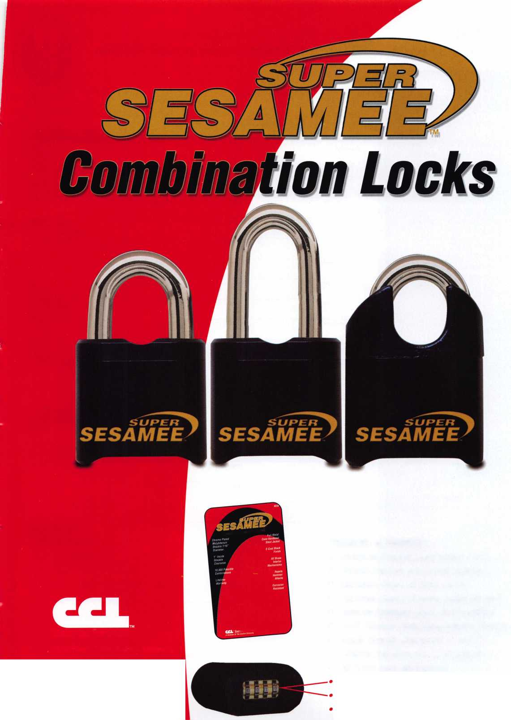

**BOARD**

nominations

What ALOA Board Positions Are Open and Where Am I Qualified to run?

There are currently seven regional directors positions open for election in addition to the position of Secretary. ALOA members now elect the directors from their own regions.

Only ALOA members from a region are eligible to run for the open posi­tion^) in that region. Only members from a nominee's region can vote for their regional candidate.

Candidates for director positions must be ALOA members for a mini­mum of three years to be eligible to run.

Members from any region who have served on the board within the preceding three years are eligi­ble to run for the Secretary posi­tion. The following vacancies will exist for the election to be held before the ALOA 2006 Convention.

Secretary

Northwest: One director

Northeast: Two directors

Southwest: One director

(one year term)

South Central: One director

International: One director

Associate: One director

If you have any questions, please contact Charles Gibson at (800) 532-2562 or e-mail [Charlie@aloa.org](mailto:Charlie@aloa.org).

On this page you will find the required nomination petition and on the following page, the board com­mitment form.

The following is the number of sig­natures required for each board position:

Secretary 25

Northwest 4

Northeast 21

Southwest 1 1

South Central 7

International 7

Associate 1

Associated Locksmiths of America, Inc.

Board of Directors Nomination Petition

Please print legibly or type. This form can be reproduced if needed.

I, the undersigned, request that, the ballot for

be placed on

(name of nominee and member number)

for the election to be held at

(position for which individual is being nominated)

the special meeting of ALOA members to be held on June 9, 2006 or any adjournment thereof.

I am eligible to vote in the region.



PRINTED NAME



PRINTED NAME



PRINTED NAME



PRINTED NAME



PRINTED NAME



PRINTED NAME



PRINTED NAME



PRINTED NAME



PRINTED NAME



PRINTED NAME

11

PRINTED NAME

12

PRINTED NAME



PRINTED NAME



PRINTED NAME



PRINTED NAME



PRINTED NAME



PRINTED NAME



PRINTED NAME



PRINTED NAME



PRINTED NAME

21

PRINTED NAME

22

PRINTED NAME



PRINTED NAME



PRINTED NAME



PRINTED NAME

MEMBER #

MEMBER #

MEMBER #

MEMBER #

MEMBER #

MEMBER #

MEMBER #

MEMBER #

MEMBER #

MEMBER #

MEMBER #

MEMBER #

MEMBER #

MEMBER #

MEMBER #

MEMBER #

MEMBER #

MEMBER #

MEMBER #

MEMBER #

MEMBER #

MEMBER #

MEMBER #

MEMBER #

MEMBER #

SIGNATURE

SIGNATURE

SIGNATURE

SIGNATURE

SIGNATURE

SIGNATURE

SIGNATURE

SIGNATURE

SIGNATURE

SIGNATURE

SIGNATURE

SIGNATURE

SIGNATURE

SIGNATURE

SIGNATURE

SIGNATURE

SIGNATURE

SIGNATURE

SIGNATURE

SIGNATURE

SIGNATURE

SIGNATURE

SIGNATURE

SIGNATURE

SIGNATURE

pTHS

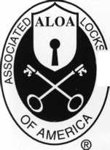

YOUR COMMITMENT TO ALOA BOARD SERVICE

(Please read carefully and sign where indicated.)

The ALOA Board governs with emphasis on organizational vision rather than on interpersonal issues of the Board; encourages diversity in viewpoints; focuses on strategic leadership rather than administrative detail; observes clear distinction between Board and Executive Director roles; makes collective rather than individual decisions; exhibits future orientation rather than past; and governs proactively rather than reactively. (For a copy of the ALOA Board of Directors Governance Policy contact the ALOA headquarters office.) The responsibilities of an ALOA board member include contributing a moderate amount of personal time, and a significant degree of professional guidance and expertise to the organization.

You will be expected to come to board meetings and the annual membership meeting. You will need to be prepared to sensibly discuss matters of great importance to your profession and participate in setting policy as part of a gov­erning body. Your course of action during your tenure on the ALOA board should be guided by fair minded, construc­tive goals pertaining to matters of consequence for ALOA and for the industry. Your contributions are expected to bene­fit ALOA as a whole, taking individual member rights and concerns into account, but free of the taint of partisan poli­tics or personal gain.

On a practical note: ALOA board members are expected to behave and dress professionally at all times, especially when actively representing the association. ALOA board members are required to participate in two board meetings per year, of three or four days in length, one each fall and spring. Board members are also asked to attend the annu­al convention and are required to attend the annual membership meeting. Board members may also be asked on a voluntary basis, to represent ALOA at related local, state or regional functions, including serving in the ALOA Booth and otherwise promoting ALOA. When travel is required for a board member, expenses covered by ALOA include lodging, travel and a reasonable per **diem.** The Board has stipulated that assigned travel will be reimbursed at the lesser of the 30-day advance tourist class airfare in effect at the time of travel or the current per-mile rate for travel by personal automobile. Spouse expenses, including extra room charges, etc., are the individual's responsibility.

• • •

I have read and agree to adhere to the ALOA Board of Directors Governance Policy. Furthermore I understand the above responsibilities of an ALOA board member, and agree to commit my time and energies as needed. I certify all of the information contained on this form and supporting documentation to be true and complete.

I can be contacted with questions at:

Address Phone #

Signed:

Date

Please attach a recent photograph of yourself along with a 75 word or less biography and retain a copy of this form for your own files. This form and all supporting documentation should be submitted no later than March 1, 2006.

Mail to:

Nominee Profile

Secretary of the Board of Directors  
Associated Locksmiths of America, Inc.  
3500 Easy Street  
Dallas, TX 75247  
1-800-532-2562

**Classifieds**

i

EMPLOYMENT

LOCKSMITH NEEDED

We are a 40-year-old rapidly growing company in need of experienced locksmiths. We provide all the tools, a brand new van, key machines, uniforms...the works. Salary is dependant upon experience and skill, very competative wage and benefits package. Paid Vacation, 401k, medical, cross training in our electronic security division and much more. We know how to treat good employees well. Please send resume or inquiry to [paulbrandon@lockguys.com](mailto:paulbrandon@lockguys.com) or call 253-839-3443

LOCKSMITH NEEDED

Large Lock shop in the Palm Springs area of California is looking for an experienced lock­smith for field work. Must be proficient in master keying, safety deposit boxes and working knowl­edge of safes. Salary plus commission, health insurance benefits, and 40IK plan. Please fax resume to 760-779-1811 or call 760-346-5214.

PROFESSIONAL EXPERIENCED LOCK­SMITH/SAFE TENICIANS WANTED:

We are in need of 1 to 2 technicians with the ability to sell, install and service all major manu­factures hardware. We are located in Knoxville, Tennessee and service all areas of east and mid­dle Tennessee. Must have a clean criminal and driving record. Must have a professional attitude and appearance. Background check and refer­ences must be supplied. Must be experienced in commercial, industrial, and residential hard­ware, sales, service, and installations. Access, SAFE, and other areas ARE a plus. Paid holi­days, retirement, health insurance, uniforms, tools and truck supplied. 8 am - PM Monday - Friday. Call:865-522-0841 Fax:865-637-2359 Email:[INFO@FMGEORGE.COM](mailto:INFO@FMGEORGE.COM) 800.484.5577 pin 0841

ACCESS CONTROL TECHNICIAN NEEDED

He/she must have 3-4 years experience in Sales & Installation of Electronic access control & cctv Installation & Service. Contact Denny Birt 1-800- 352-5034

LOCKSMITH WANTED

Busy shop in Woburn Massachusetts seeks expe­rienced locksmiths for Auto, Commercial, Residential, Safe and Card Access work. We have a large AAA area which we cover and do transponder and high security keys. Will help train in fields you are not familiar with. Sub con­tractors welcome or we will supply tools and van. Great opportunity for self-motivated individ­ual. Please sign up to join our team. Call John at 781-933-9999 or send resume to: Locks & Keys, Inc., PO Box 222, Woburn, MA 01 801. Thank you for your consideration.

LIVE, WORK & PLAY IN HAWAII

Locksmith Service Technician needed for 25- year-old company in HAWAII. Need knowledge and experience in all areas of locksmithing. Wages commensurate with experience and abili­ties. Great health and dental insurance and ben­efits. Late model van and tools provided.

Mail resume to: Paradise Lock & Safe, 350 Ward Ave., Suite 106 - 417, Honolulu, HI. 96814-4004.

WANTED TO BUY/SELL

CLEANING WAREHOUSE OVERSTOCK MUST GO

Cor-Key knobs for Schlage A/D-line hardware. S&G 6730 like new replaced with digital. Free dial and ring, Van Lock cam locks, pin kit for both cylinders and keys. Large assortment of all items. Please call for quantities and pricing. Liberty Lock & Safe 702-871-5397 ex. 2233.

BUSINESS FOR SALE

Central Florida Locksmith Business with two fully equipped vans, full inventory, tools, key and code machines, etc. Established customer base since 1983. Leased storefront shop. Gross sales 250K-300K. Priced to sell at 150K. Contact Howard at 407-933-0722.

LOOKING FOR BOOK

I am looking for The Comprehensive Manual of Locksmithing by Shankle and Shankle. Please contact Earl Karsikas at 651-769-2579 or by mail at 8257 Hyde Ave, Cottage Grove, MN 55016.

BUSINESS FOR SALE

Tired of the rat race? Here's the ideal situation for someone who wants to raise a family in the upper Mid-West or seeks a more civilized envi­ronment and still make a living comfortably. Established in 1980, we specialize in Commercial & Institutional accounts with CCTV, high security locks and access control systems.

In the heart of Wisconsin with excellent hospital and one of the nation's largest privately owned medical clinics. Contact Robert M. Dennee', Ace Lock & Security, PO Box 632, Marshfield, Wl 54449, 715-387-3064, [rdennee@tznet.com](mailto:rdennee@tznet.com), fax 715-389-8036.

FOR SALE

One Collier night depository self encased in steel, like new. TL15 Chest and UL Head with 25 keys - $3500.00. One class two vault door in good condition - $2500.00. One used 1073 diebold drive up ATM - make an offer. Many used safes please call for sizes and prices.

Buyer pays for crating and freight. Contact: Thistle Safe and Lock Co., Inc., 198 Cross St., Malden, MA 02148, 781-324-1600, [thistlesnl@aol.com](mailto:thistlesnl@aol.com)

NORTHERN CA BUSINESS FOR SALE

You now have the unique opportunity to pur­chase an established lock and safe business (1958) and clientele in a fast growing college town (Chico, CA), and possibly the plaza that houses the shop. Owner is looking to retire and owns both. We have great licensed employees, three vans, and a fully stocked shop. Please fax your references and letter of interest to: Johnny's Lock & Safe 530-873-3577.

Classified Advertising Policy

Classified advertising space is provided free of charge to ALOA members and for a fee of $2.00 per word, $40.00 minimum for non members. Classified ads may be used to advertise used merchandise and overstocked items for sale, "wanted to buy" items, business opportunities, employment opportunities/positions wanted and the like. Members or non members wishing to advertise services or new mer­chandise for sale may purchase a "Commercial Classified Ad" for a fee of $4.00 per word with a minimum of $100.00. Each ad will run for two issues. For blind boxes there is a $10.00 charge for members and non members. All ads must be submitted in writing to the Advertising Sales Department via fax at 817-645-7599 or through an email to [adsales@aloa.org](mailto:adsales@aloa.org) by the fifteenth of the month two months prior to issue date. ALOA reserves the right to refuse any classified advertisement that it deems inappropriate according to the stated purpose of the classified advertising section.

**Hardwiring Made Easy**

Make the perfect connection every  
time with SARGENT’S ElectroLynx.  
The plug-in universal connectors and  
the easy, color-coded wire system  
eliminates matching wires. Wiring is a  
snap and completely fool-proof.

SARGENT

Look for the LYNX

ELECTROi

As part of their promise to provide innovative, fast and effective, and higher security solutions to their customers, ASSA ABLOY Group  
companies offer ElectroLynx, a universal quick-connect system that simplifies the electrification of the door opening.

Dugmore introduces NEW Memphis, TN location.

DUGMORE

DUNCAN

Dugmore & Duncan is committed to getting our products to  
our customers ASAP. Our research revealed that Memphis  
TN has an innovative business plan to make the most of its  
strategic location and natural resources. It is a multi-carrier  
transportation hub.

D&D has consolidated a substantial amount of its warehouse  
inventory into a prime Memphis location. In addition to our  
current strategic points of distribution, Dugmore delivers from  
Memphis. We are confident that this is a great opportunity for  
Dugmore and for our loyal customers.

**Securing Your World**

*Distributor of*

**SARGENT**

*Products*

**Call (888) 384-6673**

FAX (888) 329-3846 • [www.dugmore.com](http://www.dugmore.com)

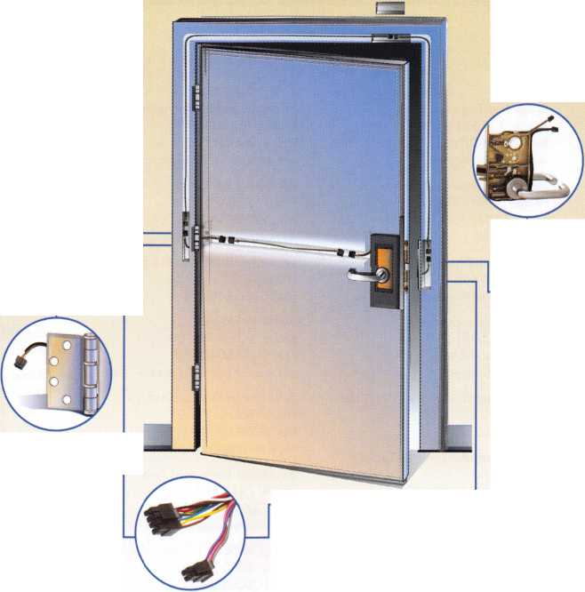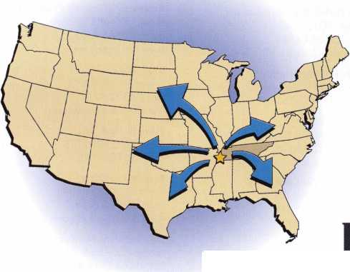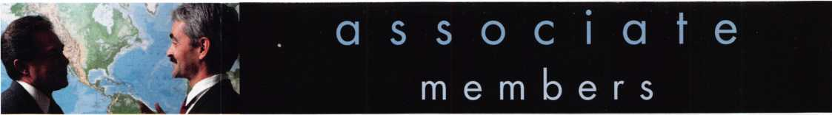

Distributor

**1 st In Hardware, Inc.**

Phone: Phone: 410-646-9900 Fax: 410-646-0045 www. 1 stinhardware.com

**Accredited Lock Supply Co.**

Phone: 800-652-2835 Fax: 201-865-0030 [www.acclock.com](http://www.acclock.com)

**Andrews Wholesale Lock Supply**

Phone: 717-272-7422 Fax: 717-274-8659 [www.andrewslock.com](http://www.andrewslock.com)

**Boyle & Chase Inc.**

Phone: 800-325-2530 Fax: 800-205-3500 [www.boyleandchase.com](http://www.boyleandchase.com)

**Clark Security Products**

Phone: 888-784-1311 Fax: 619-718-7333 [www.clarksecurity.com](http://www.clarksecurity.com)

**Cook's Building Specialties**

Phone: 505-883-5701 Fax: 505-883-5704

**Dire's Lock & Key Company**

Phone: 303-294-0176 Fax: 303-294-0198

**Direct Security Supply, Inc.**

Phone: 800-252-5757 Fax: 800-452-8600

**Discount Key Machines.Com/Busch**

Phone: 800-332-8724 Fax: 407-363-4666

**Doyle Security Products**

Phone: 800-333-6953 Fax: 612-521-0166 [www.doylesecurity.com](http://www.doylesecurity.com)

**Dugmore and Duncan, Inc.**

Phone: 888-384-6673 Fax: 888-329-3846

**E. L. Reinhardt Co., Inc.**

Phone: 800-328-1311 Fax: 651-481-0166 [www.elreinhardt.com](http://www.elreinhardt.com)

**iwert Wholesale Hardware**

Phone: 800-451-0200 Fax: 708-597-0881

**Foley-Belsaw Company**

Phone: 800-821-3452 Fax: 816-483-5010 [www.foley-belsaw.com](http://www.foley-belsaw.com)

**Fried Brothers Inc.**

Phone: 800-523-2924 Fax: 215-592-1255 [www.fbisecurity.com](http://www.fbisecurity.com)

**Hans Johnsen Company**

Phone: 214-879-1550 Fax: 214-879-1530 [www.hjc.com](http://www.hjc.com)

**Hardware Agencies, Ltd.**

Phone:416-462-1921

[www.hardwareagencies.com](http://www.hardwareagencies.com)

**IDN Incorporated**

Phone: 817-421-5470 Fax: 817-421-5468 [www.idn-inc.com](http://www.idn-inc.com)

**Instant Hardware Delivery, Inc**

Phone: 800-355-1107 Fax: 800-663-8518

**Intermountain Lock & Supply**

Phone: 800-453-5386 Fax: 801-485-7205 [www.intermountainlock.com](http://www.intermountainlock.com)

**International Electronics, Inc**

Phone: 800-343-9502 Fax: 617-821-4443

**Jo Van Distributors**

Phone:416-288-6306

Fax:416-752-8371

[www.jovanlock.com](http://www.jovanlock.com)

**Lockmasters, Inc.**

Phone: 859-885-6041 Fax: 859-885-7093 [www.lockmasters.com](http://www.lockmasters.com)

**Locks Company**

Phone: 800-288-0801 Fax: 305-949-3619

**Locksmith Ledger International**

Phone: 770-886-0800 Fax: 770-889-7703 [www.lledger.com](http://www.lledger.com)

**McDonald Dash Locksmith Supply**

Phone: 800-238-7541 Fax: 901-366-0005 [www.mcdonalddash.com](http://www.mcdonalddash.com)

**Monaco Lock Co.**

Phone: 800-526-6094 Fax: 800-845-5625 [www.monacolock.com](http://www.monacolock.com)

**Omaha Wholesale Hardware**

Phone: 800-238-4566 Fax: 402-444-1664 [www.omahawh.com](http://www.omahawh.com)

**Phoenix Safe International LLC**

Phone: 765-483-0954 Fax: 765-483-0962 [www.phoenixsafeusa.com](http://www.phoenixsafeusa.com)

**RA-Lock Company**

Phone: 972-775-6301 Fax: 972-775-6316 [www.ralock.com](http://www.ralock.com)

**Security Distributors Inc**

Phone: 800-333-6953 Fax: 612-524-0166

**Security House**

Phone: 905-669-5300 Fax: 905-660-6313 [www.securityhouselock.com](http://www.securityhouselock.com)

**Security Lock Distributors**

Phone: 800-847-5625

Fax: 800-878-6400

[www.securitylockdistributors.com](http://www.securitylockdistributors.com)

**Southern Lock and Supply Co.**

Phone: 727-541-5536 Fax: 727-544-8278 [www.southernlock.com](http://www.southernlock.com)

**Stone & Berg Wholesale**

Phone: 800-225-7405 Fax: 800-535-5625

**The Locksmith Store Inc.**

Phone: 847-364-5111 Fax: 847-364-5125 [www.locksmithstore.com](http://www.locksmithstore.com)

**Timemaster Inc.**

Phone: 859-259-1 878 Fax: 859-255-0298 [www.time-master.com](http://www.time-master.com)

**Top Notch Distributors, Inc.**

Phone: 800-233-4210 Fax: 800-854-4146 [www.topnotch.bz](http://www.topnotch.bz)

**Turn 10 Wholesale**

Phone: 800-848-9790 Fax: 800-391-4553

**U.S. Lock Corp.**

Phone: 800-925-5000 Fax: 800-338-5625 [www.uslock.com](http://www.uslock.com)

**Wilson Safe Company**

Phone: 215-492-7100 Fax: 215-492-7104 [www.wilsonsafe.com](http://www.wilsonsafe.com)

Manufacturer

**A & B Safe Corporation**

Phone: 800-253-1267 Fax: 856-863-1208 [www.a-bsafecorp.com](http://www.a-bsafecorp.com)

**ABUS Lock Company**

Phone: 800-352-2287 Fax: 602-516-9934 [www.abus.com](http://www.abus.com)

**Access Security Products Ltd.**

Phone: 905-337-7874 Fax: 905-337-7873 [www.access-safe.com](http://www.access-safe.com)

**Adams Rite Mfg Company**

Phone: 800-872-3267 Fax: 800-232-7329 [www.adamsrite.com](http://www.adamsrite.com)

**Adesco Safe Mfg. Company**

Phone: 800-694-9340 Fax: 562-408-6427 [www.adesco.com](http://www.adesco.com)

**Adrian Steel Company**

Phone: 800-677-2726 Fax: 517-265-5834 [www.adriansteel.com](http://www.adriansteel.com)

**Advanced Diagnostics USA Inc**

Phone: 650-876-2020 Fax: 650-876-2022 [www.ad-mvp.com](http://www.ad-mvp.com)

**All Five Tool Company, Inc.**

Phone: 860-583-1691 Fax: 860-583-4516 [www.all5tool.com](http://www.all5tool.com)

**American Security Products**

Phone: 909-685-9680x2013 Fax: 909-685-9685 www. a m sec usa.com

**BWD Lockcraft**

Phone: 973-728-3707 Fax: 973-728-3731 [www.bwdautomotive.com](http://www.bwdautomotive.com)

**Bianchi USA, Inc.**

Phone: 800-891-2118 Fax: 216-803-0202

**Buddy Products**

Phone: 312-733-6400 Fax: 312-733-8356 [www.buddyproducts.com](http://www.buddyproducts.com)

**CCL Security Products**

Phone: 800-733-8588 Fax: 847-537-1800 [www.cclsecurity.com](http://www.cclsecurity.com)

Keynotes • December 2005

|  |  |  |
| --- | --- | --- |
| a | s s o c i a 1 | \ e |
|  | members |  |

|  |  |  |  |
| --- | --- | --- | --- |
| CompX Security Products | Keri Systems Inc. | Rutherford Controls Int'l Co. | YSG Door Security |
| Phone: 864-297-6655 | Phone: 408-451-2520 | Phone: 519-621-7651 | Consultants, Inc. |
| Fax: 864-297-9987 | Fax: 408-441-0309 | Fax: 519-621-7939 | Phone: 800-438-1951 |
| [www.compxnet.com](http://www.compxnet.com) | [www.kerisys.com](http://www.kerisys.com) | [www.rutherfordcontrols.com](http://www.rutherfordcontrols.com) | Fax: 800-338-0965 |
| D&D Technologies (USA), Inc. | Knaack Manufacturing Co. |  |  |
| Phone: 714-677-1300x292 | Phone: 800-456-7865 | STRATTEC Security Corp. | j* • |
| Fax: 714-677-1299 | Fax: 815-459-9097 | Phone: 414-247-3333 | Service |
| [www.ddtechusa.com](http://www.ddtechusa.com) | [www.weatherguard.com](http://www.weatherguard.com) | Fax: 414-247-3564 | Organization |
| DETEX Corp. | LAB Security | [www.aftermarket.strattec.com](http://www.aftermarket.strattec.com) |
| Phone: 800-729-3839 | Phone: 800-243-8242 | Sargent & Greenleaf, Inc. | Allstate Insurance Company |
| Fax: 830-620-6711 | Fax: 860-583-7838 | Phone: 859-885-9411 | Phone: 800-859-0247 |
| [www.detex.com](http://www.detex.com) | [www.labpins.com](http://www.labpins.com) | Fax: 859-885-3063 | Fax: 847-551-2786 |
| Don-Jo Manufacturing, Inc. | La Gard Inc. | [www.sargentandgreenleaf.com](http://www.sargentandgreenleaf.com) | [www.allstate.com](http://www.allstate.com) |
| Phone: 978-422-3213 | Phone: 310-325-5670 | Sargent Manufacturing Co. | Cross Country Automotive |
| Fax: 978-422-3467 | Fax: 310-325-5615 | Phone: 800-727-5477 | Services |
| [www.don-jo.com](http://www.don-jo.com) | [www.lagard.com](http://www.lagard.com) | Fax: 888-863-5054 | Phone: 800-541-2262 |
| Door Controls International | Lock America, Inc. | [www.sargentlock.com](http://www.sargentlock.com) | Fax: 781-393-0256 |
| Phone: 800-742-3634 | dha L.A.I. Group | Schwab Corp. | [www.argosi.com](http://www.argosi.com) |
| Fax: 800-742-0410 | Phone: 714-373-2993 | Phone: 765-447-9470 | Massglass & Door Service |
| [www.doorcontrols.com](http://www.doorcontrols.com) | Fax: 714-373-2998 | Fax: 765-447-8278 | Phone: 888-742-8837 |
| FireKing Security Products  Phone: 800-457-2424 | [www.laigroup.com](http://www.laigroup.com)  Lucky Line Products, Inc. | [www.schwabcorp.com](http://www.schwabcorp.com)  Securifort Inc | Fax: 845-735-8383 [www.mechanicgroup.com](http://www.mechanicgroup.com) |
| Fax: 800-896-6606 [www.fkisecuritygroup.com](http://www.fkisecuritygroup.com) | Phone: 858-549-6699  Fax: 858-549-3241 | Phone: 819-359-2226  Fax: 819-359-2218 | The Mechanic Group Inc  Phone: 845-735-0700 |
| Framon Manufacturing | [www.luckyline.com](http://www.luckyline.com) | [www.securifort.com](http://www.securifort.com) | Fax: 805-497-2255 |
| Company Inc. | M.A.G. Manufacturing | Securitron Magnalock Corp. | [www.massglass.com](http://www.massglass.com) |
| Phone: 989-354-5623 | Phone: 714-891-5100 | Phone: 775-355-5625 | Webster Safe & Lock Co., Inc. |
| Fax: 989-354-4238 | Fax: 714-892-6845 | Fax: 775-355-5636 | Phone: 901-332-291 1 |
| [www.framon](http://www.framon) .com | [www.magmanufacturing.com](http://www.magmanufacturing.com) | [www.securitron.com](http://www.securitron.com) | Fax: 901-332-2878 |
| HY-KO Products Co. | MUL-T-LOCK USA, Inc. | Security Door Controls | [www.webstersinc.com](http://www.webstersinc.com) |
| Phone: 330-467-7446 | Phone: 800-562-351 1 | Phone: 805-494-0622 |  |
| Fax: 330-467-7442 | Fax: 973-778-4007 | Fax: 805-494-8861 |  |
| Hammerhead industries, Inc. | [www.mul-t-lockusa.com](http://www.mul-t-lockusa.com) | [www.sdcsecurity.com](http://www.sdcsecurity.com) |  |
| Phone: 805-658-9922 | Major Mfg, Inc. | Security Solutions |  |
| Fax: 805-658-8833 | Phone: 714-772-5202 | Phone: 405-376-1600 |  |
| [www.gearkeeper.com](http://www.gearkeeper.com) | Fax: 714-772-2302 | Fax: 405-376-6870 |  |
| Ingersoll Rand SSA | [www.majormfg.com](http://www.majormfg.com) | [www.securitysolutions-usa.com](http://www.securitysolutions-usa.com) |  |
| Phone: 317-613-8025 | Maxcess Card Systems Ltd | Sun Safes Manufacturing Co. |  |
| Fax: 317-613-8068 | Phone: 949-492-5964 | Phone: 823-194-5930 |  |
| [www.schlagelock.com](http://www.schlagelock.com) | Fax: 949-492-0415 | Phone: 823-194-5940 |  |
| Jackson Corporation | [www.maxcess-card.com](http://www.maxcess-card.com) | Townsteel, Inc. |  |
| Phone: 323-269-8111 | Medeco Security Locks | Phone: 626-858-5080 |  |
| Fax: 800-888-6855 | Phone: 540-380-5000 | Fax: 626-858-3393 |  |
| [www.jacksonexit.com](http://www.jacksonexit.com) | Fax: 540-380-5010 | [www.townsteel.com](http://www.townsteel.com) |  |
| Jet Hardware Mfg., Co. | [www.medeco.com](http://www.medeco.com) | UCA Inc |  |
| Phone: 718-257-9600 | Mil-Comm Products Co Inc | Phone: 972-312-0599x12 |  |
| Fax: 718-257-0973 | Phone: 201-935-8561 | Fax: 972-692-7056 |  |
| www. j etkey s .com | Fax: 201-935-6059 | [www.ibuttonlock.com](http://www.ibuttonlock.com) |  |

**KABA ILCO Corp.**

Phone: 252-446-3321 Fax: 252-446-4702 [www.kaba-ilco.com](http://www.kaba-ilco.com)

**KEY-BAK/West Coast Chain Mfg.**

Phone: 909-923-7800 Fax: 909-923-0024 [www.keybak.com](http://www.keybak.com)

**Protex Safe Co., LLC**

Phone: 818-610-8030 Fax: 818-610-8004 [www.protexsafe.com](http://www.protexsafe.com)

**ROFU International Corp.**

Phone: 253-922-1828 Fax: 253-922-1728 [www.rofu.com](http://www.rofu.com)

**Ultra Lift Corporation**

Phone: 800-346-3057 Fax: 408-297-1199 [www.ultralift.com](http://www.ultralift.com)

**Videx Inc.**

Phone: 541-758-0521 Fax: 541-752-5285 [www.videx.com](http://www.videx.com)

Keynotes • December 2005



US H 3632

SPONSOR: LaTourette (R)

TITLE: Electronic Premise Security Systems

INTRODUCED:

07/29/2005

DISPOSITION: Pending

LOCATION: House Ways and Means Committee

SUMMARY:

Allows a deduction for expenses related to the purchase and instal­lation of qualifying electronic premise security systems.

STATUS:

* 07/29/2005 INTRODUCED.
* 07/29/2005 To HOUSE Committee on WAYS AND MEANS.

CA A 714

AUTHOR: Ridley-Thomas (D)

TITLE: Motor Vehicles: Key Information Access

INTRODUCED:

02/17/2005

LAST AMEND:

09/08/2005

DISPOSITION: Pending - Carryover

LOCATION: Assembly Transportation Committee

SUMMARY: Requires every motor vehicle manufacturer of a motor vehicle sold or leased in this state with a model year of 2007 or later to provide a means whereby the registered owner of that motor vehicle can access information suf­ficient to permit the reproduction of a key to operate the owner's vehicle 24 hours each day and 7 days each week.

STATUS:

* 02/17/2005 INTRODUCED.
* 09/07/2005 To ASSEMBLY Committees on TRANSPORTA­TION and BUSINESS AND PROFESSIONS.
* 09/08/2005 From ASSEMBLY Committee on TRANSPORTA­TION with author's amend­ments.
* 09/08/2005 In ASSEMBLY. Read second time and amend­ed. Re-referred to Committee on TRANSPORTATION.

IN H 1361

AUTHOR: Brown C (D)

TITLE:Locksmith

Registration

INTRODUCED:

01/13/2005

DISPOSITION: Failed - Adjourned

LOCATION: House Public Safety and Homeland Security

SUMMARY: Requires locksmiths to be registered; requires the state police department to administer the registration program and con­duct a national criminal history background check for each regis­tration applicant.

STATUS:

* 01/13/2005 INTRODUCED.
* 01/13/2005 To HOUSE Committee on PUBLIC SAFETY AND HOMELAND SECURITY. NOTES:Locksmith Registration

MD H 207 CROSS- FILED WITH:MD S 105

AUTHOR: Hubbard (D)

TITLE: Maryland Security Systems Training Board

INTRODUCED:

01/24/2005

DISPOSITION: Failed - Adjourned

LOCATION:

HOUSE

SUMMARY: Establishes the Maryland Security Systems Training Board; requires the Secretary of State Police to adopt regulations to implement training requirements for security systems technicians developed by the Maryland Security Systems Training Board; provides for the composition of the Board and the terms, removal, and compensation of the members of the Board; authorizes the Board to set speci­fied fees; requires the Board to set training requirement.

STATUS:

* 01/24/2005 INTRODUCED.
* 01/24/2005 To HOUSE Committee on ECONOMIC MATTERS.
* 02/21/2005 From HOUSE Committee on ECONOMIC MATTERS: Reported unfavorably.

NOTES:Security Systems Training Board

MO S 1 86

SPONSOR: Loudon (R)

TITLE: Electrical Industry Licensing Board

INTRODUCED: 01/18/2005 DISPOSITION: Failed - Adjourned

LOCATION: Senate Financial and Governmental Organization, Veterans' Affairs and Elections Committee

SUMMARY: Establishes the

Missouri Electrical Industry Licensing Board and describes their powers and duties.

STATUS:

* 01/18/2005 INTRODUCED.
* 01/24/2005 To SENATE Committee on FINANCIAL, GOVERNMENTAL ORGANIZATIONS, AND ELECTIONS.

NOTES:Electrical Industry Licensing Board

MS S 2356

AUTHOR: Mettetal (D)

TITLE: Burglar Alarms INTRODUCED: 01/13/2005 DISPOSITION: Failed LOCATION: Died

SUMMARY: Burglar alarms; license and regulate installation.

STATUS:

* 01/13/2005 INTRODUCED.
* 01/13/2005 To SENATE Committee on BUSINESS AND FINANCIAL INSTITUTIONS.
* 02/01/2005 Died in committee.

NOTES:Burglar Alarm License

NJ ]A 3943 IDENTICAL: NJ S 2337

SPONSOR: Johnson (D)

TITLE: Electronic Security Systems PREFILED: 03/14/2005

INTRODUCED:

05/02/2005

DISPOSITION: Pending

LOCATION: Assembly Regulated Professions and Independent Authorities Committee

SUMMARY: Exempts certain businesses from licensing requirements for those engagedin burglar alarm, fire alarm and electronic security system installa­tions.

STATUS:

* 03/14/2005 FILED.
* 05/02/2005 INTRODUCED.
* 05/02/2005 To ASSEMBLY Committee on REGULATED PROFESSIONS AND INDEPENDENT AUTHORITIES. NOTES:Electronic Security Systems

PA H 1653 PN: 2080

AUTHOR: Raymond (R)

TITLE: Vehicles Code PREFILED: 06/06/2005

INTRODUCED:

06/07/2005

DISPOSITION: Pending

LOCATION: House Transportation Committee

SUMMARY: Amends the Vehicles Code. Provides for duplicate vehi­cle keys.

Prescribes a penalty.

STATUS:

* 06/06/2005 FILED.
* 06/07/2005 INTRODUCED.
* 06/07/2005 To HOUSE Committee on TRANSPORTATION.

TN S

2024SAME AS:TN H 1731

AUTHOR: Cooper (D)

TITLE: Locksmith Licenses

INTRODUCED:

02/16/2005

LAST AMEND: 04/28/2005

DISPOSITION: Pending - Carryover

LOCATION:

HOUSE SUMMARY:

Requires locksmiths to be licensed; requires licenses to be obtained from the commissioner of com­merce and insurance.

STATUS:

* 02/16/2005 INTRODUCED.
* 02/23/2005 To SENATE Committee on GOVERNMENT OPERATIONS.
* 03/30/2005 From SENATE Committee on GOVERNMENT OPERATIONS: Recommend passage.
* 64/28/2005 In SENATE. Amendment No. 1 (SA0172) adopted on SENATE floor.
* 04/58/2005 In SENATE. Amendment No. 2 (SA0173) adopted on SENATE floor.
* 04/58/2005 In SENATE. Amendment No. 3 (SA0304) adopted on SENATE floor.
* 04/58/2005 In SENATE. Amendment No. 4 (SA0407) adopted on SENATE floor.
* 04/58/2005 In SENATE. Amendment No. 5 (SA0408) adopted on SENATE floor.
* 04/58/2005 In SENATE. Read third time. Passed SENATE.

To HOUSE.

NOTES:Locksmith License.

TX H 2243

AUTHOR: Jackson (R)

TITLE: Regulation of Locksmiths and Locksmith Companies

INTRODUCED: 03/08/2005 LAST AMEND: 05/16/2005 ENACTED: 06/18/2005

DISPOSITION: Enacted LOCATION: Chaptered CHAPTER: 1102

SUMMARY: Relates to the regula­tion of locksmiths and locksmith companies under the Private Security Act; provides that a lock­smith company or locksmith may not perform services for a cus­tomer who seeks entry to a struc­ture, motor vehicle, or other prop­erty unless the customer, shows the locksmith company or lock­smith a government-issued identifi­cation and provides a signed authorization stating that the cus­tomer or is entitled to legal access to the structure, motor vehicle, or other property.

STATUS:

* 03/08/2005 INTRODUCED.
* 03/14/2005 To HOUSE Committee on LICENSING AND ADMINISTRATIVE PROCE­DURES.
* 04/06/2005 From HOUSE Committee on LICENSING AND ADMINISTRATIVE PROCEDURES: Reported favor­ably with substitute.
* 04/14/2005 Committee report printed and distributed.
* 04/29/2005 Amended on HOUSE floor.
* 04/29/2005 Passed HOUSE. To SENATE.
* 05/03/2005 To SENATE Committee on BUSINESS AND COMMERCE.
* 05/16/2005 From SENATE

Committee on BUSINESS AND COMMERCE: Reported favorably with substitute.

* 05/16/2005 Committee report printed and distributed.
* 65/24/2005 Passed SENATE. To HOUSE for concurrence.
* 05/26/2005HOUSE concurred in SENATE amendments.
* 06/02/2005 To GOVERNOR.
* 06/18/2005 Signed by GOVERNOR.
* 07/25/2005 Filed with Secretary of State. Chapter No. 1102

NOTES:Regulation of Locksmiths and Locksmith Companies

TX H ]3140

AUTHOR: Hughes (R)

TITLE: Private Security Regulation INTRODUCED: 03/11/2005 LAST AMEND: 04/25/2005 ENACTED: 06/18/2005 DISPOSITION: Enacted LOCATION: Chaptered CHAPTER: 1155

SUMMARY: Relates to exemption of certain electronic access control device or alarm system manufac­turers or providers from private security regulation; provides that an alarm system does not include a telephone entry system, opera­tor for opening or closing a resi­dential or commercial door or an

accessory to activate a gate or door that is not connected to an alarm system; provides that an electronic access control device includes a telephone entry system into an area not monitored by security personnel.

STATUS:

* 03/11/2005 INTRODUCED.
* 03/21/2005 To HOUSE Committee on LAW ENFORCE­MENT.
* 04/25/2005 From HOUSE Committee on LAW ENFORCE­MENT: Reported favorably with substitute.
* 04/30/2005 Committee report printed and distributed.
* 65/13/2005 Passed HOUSE. To SENATE.
* 05/17/2005 To SENATE Committee on BUSINESS AND COMMERCE.
* 05/19/2005 From SENATE Committee on BUSINESS AND COMMERCE: Reported favor­ably.
* 05/19/2005 Committee report printed and distributed.
* 65/25/2005 Passed SENATE.
* 06/02/2005 To GOVERNOR.
* 06/18/2005 Signed by GOVERNOR.
* 07/25/2005Filed with Secretary of State. Chapter No. 1 155

TX S 1365

AUTHOR: Armbrister (D)

TITLE: Alarm Systems

INTRODUCED: 03/10/2005

DISPOSITION: Failed - Adjourned

LOCATION: Senate Intergovernmental Relations Committee

SUMMARY: Relates to the regula­tion of alarm systems and alarm systems companies.

STATUS:

* 03/10/2005 INTRODUCED.
* 03/21/2005 To SENATE Committee on INTERGOVERN­MENTAL RELATIONS. NOTES:Alarm Systems defini­tion change.

Wl S 210

AUTHOR: Leibham (R) TITLE:Motor Vehicle Key INTRODUCED: 05/19/2005 DISPOSITION: Pending

LOCATION:Senate Natural Resources and Transportation Committee

SUMMARY: Relates to reproduc­tion of a motor vehicle key based upon the vehicle's identification number. Provides a penalty.

STATUS:

* 05/19/2005 INTRODUCED.
* 05/19/2005 To SENATE Committee on NATURAL RESOURCES AND TRANSPORTATION.

**THE HINGE DOCTOR**

**by GKL Products**

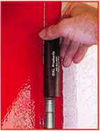

**HA1 For  
Standard**

**Commercial**

**4-1/2" x 4-1/2'**

**Butt Hinges**

**HA2**

*"The HULK*

**For Residential Hinges**

**COMING IN  
SEPTEMBER**

**HA3**

**For Ball- Bearing**

**Commercial Hinges**

**The Hinge Doctor is a great way to repair those sagging metal  
doors. Slip the tool over the hinge and open the door an inch**

**or two past the point where the tool binds against the  
hinge, remove the tool and check the door,**

**which should now be working properly.**

**If you're a locksmith these tools  
will turn a profit the 1st time you  
use them!  
Uses - schools, hospitals,**

**commercial buildings, storefronts**

**with butt hinges, office doors, new**

**construction, door alignment, sagging**

**doors, jail cells, anywhere there are  
commercial grade hinges.**

**HA4**

**For Prison**

**& Institutional**

**Hinges &**

**Spring Hinges**

Over

US Patent

#6450003

**[www.hingedoctor.com](http://www.hingedoctor.com)**

800-924-5397

10,000

Satisfied

Customers

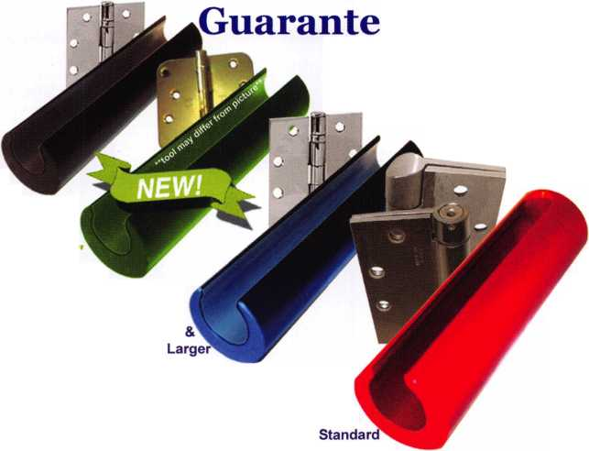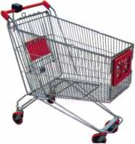

keynotes

Buyer's Marketplace

YOUR x NAME HERE 1-800-355-6322

CALL C 1-800-355-6322 For More / „ Information '

^OERt^

**ADVERTISE WITH  
OUR**

**WEATHERPROOF**

**LABLES**

Professional Business Products

We offer lower prices on standard and custom invoices/work orders, checks, business cards, repair tags, key tags, magnets and much more.

Call today for our brochure and samples.

[www.pbp2000.com](http://www.pbp2000.com)

Accept Credit Cards!

In your Locksmithing Business,  
Storefronts/Offices/Homebased

Businesses

**No application fees**

**No Monthly Minimum**

**No Lease Requirements**

**0nsite wireless terminals available**

RETRIEVER PAYMENT

SYSTEMS

888-549-6424

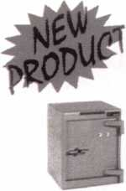

FROM A & B SAFE CORP.

A & B Chest  
Model WS-0

Equipped with dual key,  
combination or  
electronic locking  
slot optional

A & B SAFE CORPORATION

171 S, Del sea Dr  
Giossboro, NJ 08028-6237  
856-863-1186 Fax 856-863-1208

**New!** Keedex Stainless Steel Armored Door Loops

ALL

STAINLESS STEEL  
DESIGN

FLEXIBLE STAINLESS  
STEEL CONDUIT

STAINLESS STEEL  
END PIECES

STAINLESS STEEL  
MOUNTING SCREWS

COSTS NO MORE  
THAN MOST DOOR  
LOOPS THAT HAVE  
PLASTIC END PIECES

Call or write today for yourfree catalog!

AVAILABLE FROM YOUR KEEDEX DISTRIBUTOR

MADE IN U.S.A.

Keedex, Inc.

12931 Shackelford Lane



Garden Grove, CA 92841  
714-636-5657 • Fax: 714-636-5680

"Ideas That Work"

e-mail: [info@keedex.com](mailto:info@keedex.com)

[www.keedex.com](http://www.keedex.com)

Keynotes • December 2005

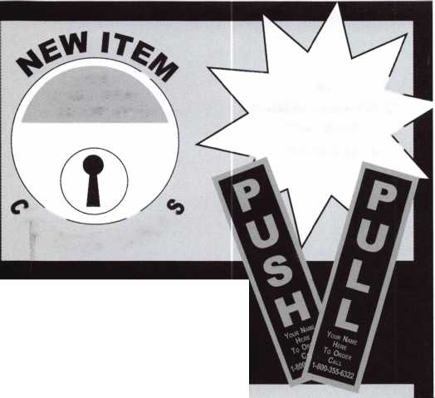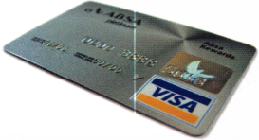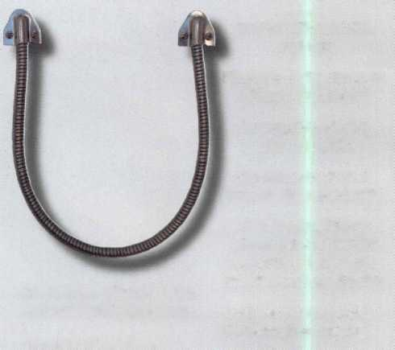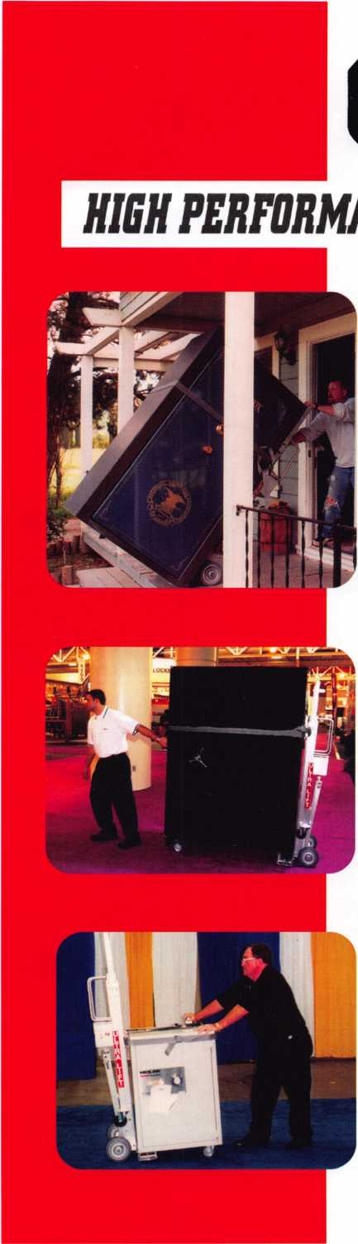

***OPERATOR SAFETY***

Injuries can be virtually eliminated. Ultra Lift does the lift­ing so that operator effort required to complete a move is minimized. Heavy loads are broken back with ease. The operator stays in control by using a combination of motor power, balance and leverage in every phase of a move.

***REDUCE LABOR COSTS***

Fewer people are required for any move with Ultra Lift. Manpower can be scheduled more productively. Labor savings often pay for the Ultra Lift in one month.

***ELIMINATE DAMAGE***

Loads are broken back, set down and moved under power with maximum leverage and operator control. Gentle handling eliminates bumps, bounces and damage to the load and premises.

***INCREASE PROFITS***

Increased operator safety, reduced labor cost and elimina­tion of damage to the load and premises ail contribute to significant increases in profits.

FOR LITERATURE, VIDEO OR ON-SITE DEMONSTRATION, WRITE OR CALL:

ULTRA LIFT CORPORATION

475 STOCKTON AVENUE, UNIT E SAN JOSE, CA 95126 800-346-3057 408-287-9400 FAX 408-297-1199 E-mail: [info@uItraIift.com](mailto:info@uItraIift.com) [www.ultralift.com](http://www.ultralift.com)

ULTRA LIFT supplies the power — so you don't have to. One person can safely and easily handle loads that usually require 2 or 3 people, even up or down stairs. TWo people can handle most safes to 1500 pounds. If safety is your concern, ULTRA LIFT is the best move you'll ever make!

U.S. PATENT 4.570.953

On the Road  
with the Board

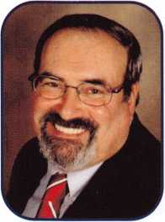

Dear Members,

On October 26th through the 30th the Greater Philadelphia Locksmiths' Association held their 56th Convention. ALOA was well represented. David Lowell, Bill Gibson, Vernon Kelley, Joe Lee, Hans Mejlshede, John Greenan, Bill Young and I me with attendees and fellow ALOA members, manned the ALOA booth, attended the banquet and when time permitted went outside to admire the T-Bird. All the gentlemen mentioned, with the exception of David and Bill Gibson are member of GPLA.

During the convention, Bill, Bill, David, Vernon, and I had a meeting with a committee from the Board of Directors of the Institutional Locksmiths' Association to discuss how we could work together in the future. At the show, itself, the T- Bird made a big hit with the attendees. Later that evening at the banquet, Bill Gibson received the "Lee Rognan Award" for promoting communication and cooperation among associations.

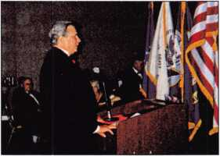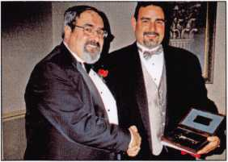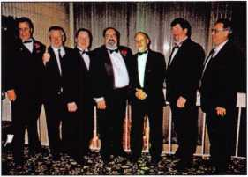

Bill Gibson at the podium.

Bob Mock congratulating Mark Miller, recipient of the '06 Philadelphia Award.

ALOA attendees (from left) - Bill Gibson,  
Hans Mejlshede, Vernon Kelley, Bob Mock,  
Bill Young, John Greenan, David Lowell.

Earlier in the month of October, I was keynote speaker at the Institutional Locksmiths' Association Conference in Secau- cus, New Jersey. There, at the banquet, Northeast Director Vernon Kelley received an award for his service to the ILA.

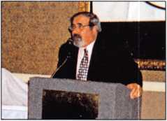

Keynote Speaker, Bob Mock,  
at ILA podium

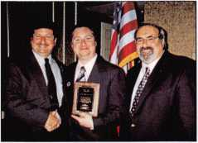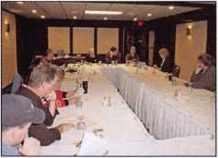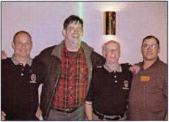

Kurt Kloeckner, National President  
of ILA congratulates Vernon Kelley  
as Bob Mock looks on.

Bill Smith and I attended the Indianhead Chapter of ALOA meeting on Satur-  
day in Chippewa Falls, Wisconsin. They are a vibrant chapter. Bill Smith is  
hoping to return there in January to install their newly elected slate of officers.

Is there anything going on in your local association? Would you like one of us to attend? Let us know. Have a joyous and peaceful holiday season.



Keynotes • December 2005

Alberto, 11 years Machine Operator

SECURITY PRODUCTS

Raymond, 4 years Accounting

Shirley, 23 yd Lock Assemb

years er Service

We represent the 500 employees of CompX Security Products.

Hardworking. Reliable. Dedicated.

And it shows in the products we make.

Is it any surprise that, year after year, you the locksmith community, choose to partner with us?

Made in America does matter to you, and it matters to us. Through our four US facilities, we will continue to provide you with the high quality products you have come to expect from CompX Security Products.

*Cbm&C*

CHICAGO

FORT

*TIMBERLINE*

*SLAIinMA L*

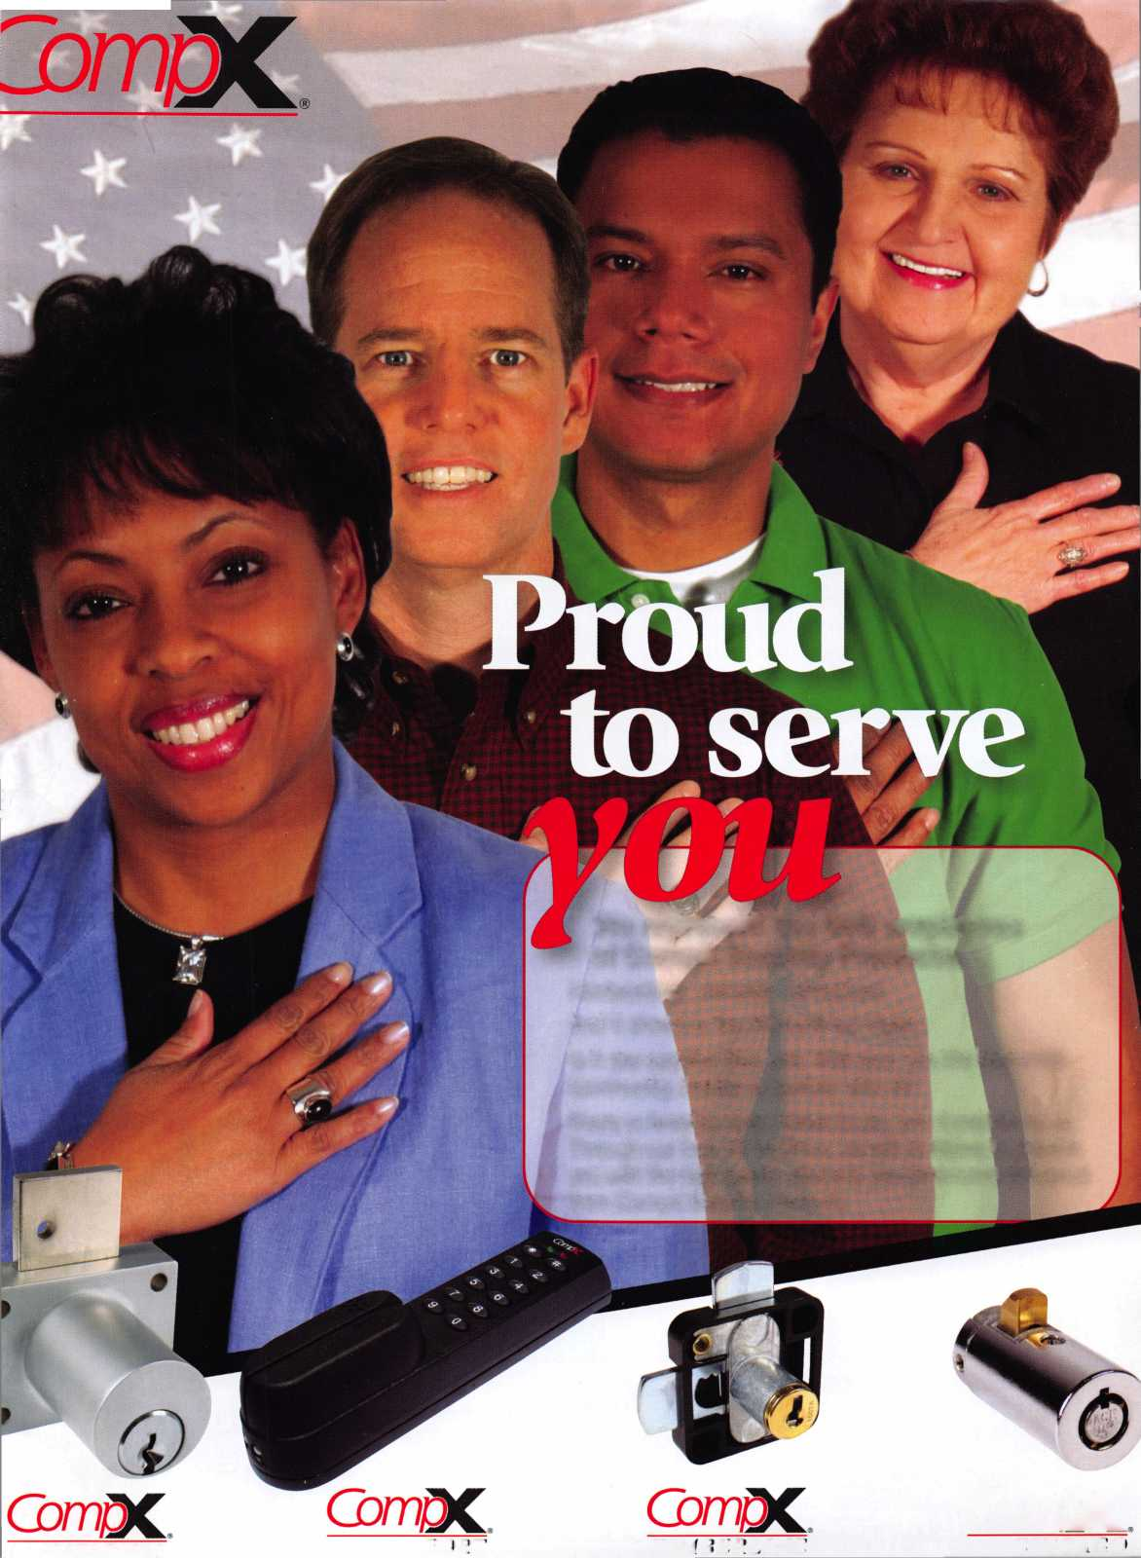

**The most reliable unit available for transponder key programming and PATS system diagnostics on ALL Ford Lincoln/Mercury and Mazda* vehicles.**

***TOLL FREEt[chsupport***

***800/342 5080***

**HICKOI**

**CAN Vehicle Interface Module**

**Model Software Update now|avaj]SBj€**

Locksmith 8008LXLC

eras!

h Kit 8008LXLC

ith VIM

IVIGS XL CAIM Locksmi

* NGS XL Tester and Locksr
* NGS XL CAN VIM
* 1996-Current Model Year Ford Transponder

PATS Reprogramming Software

* FREE - 2 Additional Years of Software
* 81204 - CAN Vehicle Interface Cable
* 81205 - CAN Power Cable
* 800N - OBDII/EEC-V Cable
* HI 05-00100 - Central Security Module Cable
* NGS/Locksmith/PATS Instruction Manual
* Key Blank/System Quick Reference Card
* Transponder Marketing Support Pack
* Blo-molded Carrying Case
* 13 Month Warranty

CAN VIM

81201L

NGS CAN VIM Kit 81201L

* NGS CAN Vehicle Interface Module (VIM)
* 81204 - CAN Vehicle Interface Cable
* 81205 - CAN Auxiliary !
* 2003-2005 CAN Softv
* 2005 Non-CAN Softwar
* Operator’s Manual
* Key Blank Quick Refers

sr Cable Card Cards

m

ii

Chart

